CSA05 – DATABASE MANAGEMENT SYSTEMS
Assignment 1 – CO1
Design, Analyse and Validate a Storage and Indexing Strategy for the Museum Condition-Report Database
Scenario: Meridian Museum – Collection Loans and Exhibition Planning
Particulars | Details
Name | S. Samyuktha
Register Number | 1924260064
Department | Artificial Intelligence and Data Science
Year | 2026
Course | CSA05 – Database Management Systems
Nature of assignment | Individual (Total marks: 50)
DBMS used for implementation | MySQL-compatible InnoDB (MariaDB 10.11 server), generator seed 4211

Contents
- Case scenario and working assumptions
- Task 1 – Requirements and alternative conceptual designs (5)
- Task 2 – Entities, attributes and keys (2)
- Task 3 – Relationships and structural constraints (6)
- Task 4 – Chen ER diagram (4)
- Task 5 – EER model (3)
- Task 6 – Weak entities and complex attributes (3)
- Task 7 – Relational mapping (4)
- Task 8 – Implementation and populated instances (4)
- Task 9 – Validation with use-case queries (3)
- Task 10 – Comparison with file-based, hierarchical and network models (4)
- Task 11 – Final design recommendation (4)
- Task 12 – Re-evaluation under changed ownership requirement (8)
- Appendix A – Data-generation script | Appendix B – Re-run instructions

Case scenario and working assumptions
Scenario (as given). Meridian Museum borrows artifacts for temporary exhibitions. The same artifact has different catalog descriptions in the loan register and gallery plan. Loan expiry dates are not linked to display slots, and condition reports are filed by lender name rather than by physical object. The design must separate ownership, temporary custody, exhibition placement and condition evidence. The fictional museum maintains 8 collection units, 35 curators, 1,200 lenders and 9,000 cataloged artifacts. Each artifact has one current lender. A loan belongs to one lender and contains multiple artifacts. Display slots are numbered within an exhibition. An artifact can have successive loans, and a curator may also lend a privately owned object.
Design challenge (Task 12). Artifacts may have shared legal ownership, and ownership shares can change while an existing loan remains in force. The custody record must remain distinct from the ownership history.
Working assumptions used throughout (stated so every later decision can be traced):
- The four evidence-bearing concepts are kept apart: ownership (who legally owns an artifact), custody (a LOAN occurrence and its LOAN_OBJECT lines), placement (an object in a numbered DISPLAY_SLOT of an EXHIBITION) and condition evidence (CONDITION_REPORT about one physical object on one loan).
- “Today” for all date-dependent queries is 1 November 2026.
- The museum has 35 curators and 5 registrars (40 employees). Three curators also lend privately owned objects, so they appear in both LENDER and EMPLOYEE.
- A loan's artifacts all come from the one lender who signs it; an artifact never sits on two loans whose periods overlap (a cross-row rule, enforced by trigger in Task 8).
- The server is MariaDB 10.11 (MySQL-compatible InnoDB). Error numbers differ slightly from Oracle MySQL 8 (for example a failed CHECK is 4025 here and 3819 in MySQL 8); the DDL itself is portable.

Task 1 – Analyse the Requirements and Propose Alternative Conceptual Designs [5 Marks]
QUESTION | TASK 1 – Analyse the Requirements and Propose Alternative Conceptual Designs [5 Marks]
Investigate Meridian Museum and construct three alternative conceptual approaches to loan coordination, paying particular attention to custody periods and condition evidence. Distinguish legal ownership, loan custody and exhibition placement.
Distinguish the alternatives by identity, relationship degree or historical representation. Show why merely renaming LOAN would leave the same model.
For each alternative, address the following case-specific requirements: Illustrate this through custody periods and condition evidence.
• Identify the operational users who create LOAN records and the information they must share.
• Contrast a dated relationship representation of loan coordination with an independently identified LOAN occurrence.
• Compare separate LENDER and employee records with shared PERSON identity when roles overlap. Illustrate this through custody periods and condition evidence.
• Explain how the proposed structure preserves custody periods and condition evidence.
• Sketch the core of each design, including the ownership of LOAN_OBJECT evidence.
• State a concrete failure case that each alternative is intended to resolve. Illustrate this through custody periods and condition evidence.
Choose the alternatives from the rules of Meridian Museum; support the comparison with a counterexample drawn from this case.
Evidence Expected
Three meaningfully different conceptual designs supported by requirement analysis, ER sketches and a justification of each modelling choice.

ANSWER

1.1 Operational users and the information they must share
User | What they create or use | Information that must be shared
Registrar (loans desk) | Creates the LOAN record and its LOAN_OBJECT lines; files CONDITION_REPORTs at check-in, inspection and check-out | Lender identity, loan period, artifact catalog numbers, insured value per line, condition grade
Curator | Proposes the loan, is its responsible curator; may also be a lender of a private object | Lender identity, artifact, exhibition intent, expiry date
Gallery planner | Creates PLACEMENT of a loan line into a numbered DISPLAY_SLOT | Loan line identity (loan + artifact), display dates, slot, exhibition
Lender or representative | Signs the loan, supplies contact for notifications | Legal name, contact details (person or organisation), objects offered

Alternative A, B and C below differ in how the loan is identified (identity), how many participants the loan relationship has (degree) and how history is stored (historical representation).
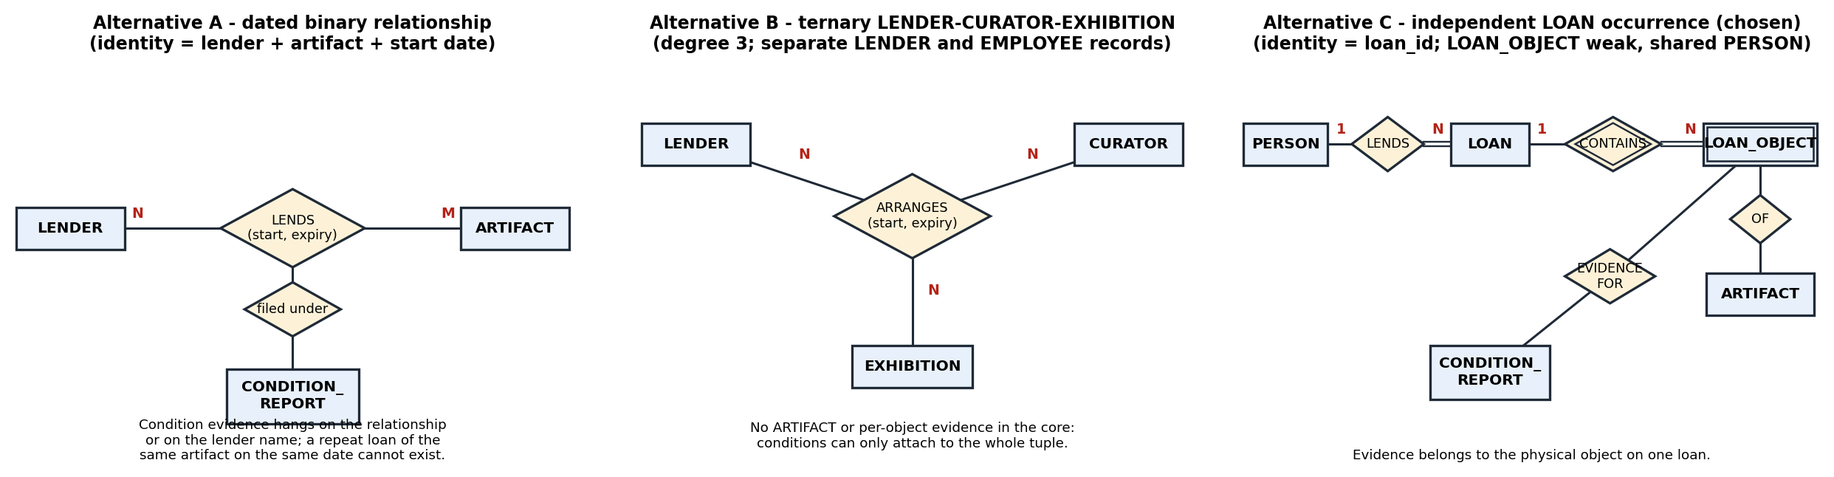
Figure 1 – Sketch of the core of the three conceptual alternatives (chosen design: C).

1.2 The three alternatives compared on the required points
Required point | A – Dated binary relationship | B – Ternary LENDER–CURATOR–EXHIBITION | C – Independent LOAN + LOAN_OBJECT + shared PERSON
Identity of a loan | None of its own: (lender, artifact, start date) must be unique | None of its own: the triple (lender, curator, exhibition) | LOAN_ID is a stable surrogate; the business story (lender, period, curator) is stored as attributes
Relationship degree | Binary M:N LENDER–ARTIFACT with attributes start, expiry | Ternary; artifacts are not even participants | Two binaries and one weak entity: LENDER 1:N LOAN, LOAN 1:N LOAN_OBJECT, ARTIFACT 1:N LOAN_OBJECT
Historical representation | Dated relationship: one tuple per artifact per loan; ‘loan’ is only a shared date value | Dated ternary instance; a repeat of the same triple needs another date | Each loan is a distinct occurrence; successive loans of an artifact are successive LOAN_OBJECT rows
Dated relationship vs independently identified LOAN | Dated relationship; two artifacts lent together cannot be shown to be one loan | Dated relationship again | Independently identified: expiry is stored once and display slots can reference the line
LENDER/employee records vs shared PERSON | Separate LENDER and EMPLOYEE tables: a curator lending a private object is two people | Separate records, and CURATOR is a ternary participant | Shared PERSON: one identity plays lender and curator roles (see Task 5)
How custody periods are preserved | Only through repeated dates on every tuple | Only through the triple’s dates | LOAN.loan_start/loan_expiry/returned_on plus status; period never shared across loans
How condition evidence is preserved | Hangs on the relationship tuple or on a lender name | Hangs on the whole triple, so it cannot name an object | CONDITION_REPORT owned by LOAN_OBJECT (loan_id, artifact_id): evidence belongs to the physical object on one loan
Concrete failure case it is meant to resolve | Condition reports filed by lender name: a lender with 7 objects on loan, a ‘lender-level’ report cannot say which was damaged. A resolves it by keying evidence to an artifact | Loan expiry not linked to display slots: B puts EXHIBITION inside the relationship so expiry and exhibition travel together | Same artifact described differently in loan register and gallery plan: C has one ARTIFACT identity referenced from every loan line and placement

1.3 Why merely renaming LOAN would leave the same model
Calling the LENDS relationship of Alternative A ‘LOAN’ changes only a label. Its identity is still the participants plus a date, its degree is still two, and its history is still one dated tuple per artifact. It is therefore the same model, and every defect of A survives the rename. Counterexample from this case: a lender sends artifacts X and Y together under one agreement expiring 31 Dec. A stores two LENDS tuples (L,X,start) and (L,Y,start). If the registrar extends the expiry on the tuple for X only, the database now says the ‘same loan’ expires on two dates and nothing in the schema shows they were one loan. A true LOAN entity with LOAN_ID stores the expiry once. A similar counterexample defeats B: Lender L with Curator C in Exhibition E may borrow in spring and again in autumn; the two loans collapse onto the single triple (L,C,E).

1.4 Choice
Alternative C is chosen because it is the only one that gives the loan its own identity, keeps ownership separate from custody (the lender is an attribute of the loan and artifact, not the loan itself), allows a PLACEMENT to reference a loan line, and lets a condition report belong to a physical object on one loan. The remaining tasks develop, implement and test C; Task 12 re-tests all three alternatives against the shared-ownership rule.

Task 2 – Identify Entities, Attributes and Keys [2 Marks]
QUESTION | TASK 2 – Identify Entities, Attributes and Keys [2 Marks]
Build an entity and key catalog for the loan coordination models, distinguishing real-world identity from record labels. Decide whether an exhibition name can identify a display slot.
Discuss:
• Identify independently identifiable objects and existence-dependent DISPLAY_SLOT records.
• Classify contact information, CollectionType, source dates and calculated summaries by attribute type.
• Select stable primary keys, business candidate keys and owner-scoped keys for DISPLAY_SLOT.
• Explain how concurrent registration at Meridian Museum avoids issuing the same identifier twice.
Justify every key using the stated loan coordination rules, including a reason why a name is not a reliable identifier.
Evidence Expected
Correct identification and justification of entity types, attribute types and keys.

ANSWER

2.1 Entity and key catalogue
Entity | Kind | Primary key (stable) | Business candidate / scoped keys | Why this key
PERSON | Strong, supertype | person_id (surrogate) | email (unique) | Names are not unique: in the 1,000-lender database 271 person names occur more than once
LENDER | Subtype of PERSON | person_id | – | A lender is a role of a person, so it shares the person’s identity
EMPLOYEE (CURATOR, REGISTRAR) | Subtype of PERSON | person_id | – | Same identity as the person; emp_role decides the subtype
ORGANIZATION | Strong | org_id | org_name is NOT unique | Trust names are re-used/re-spelt
NOTIFICATION_CONTACT | Category (union) entity | contact_id | exactly one of person_id / org_id | Contact may be a person or an organisation
ARTIFACT | Strong | artifact_id (surrogate) | catalog_no (unique, e.g. MM-0000123) | Titles repeat: 1,628 distinct titles are shared by 2+ artifacts at 1,000 lenders
COLLECTION_TYPE / COLLECTION_UNIT | Strong lookup | type_code / unit_id | type_name, unit_name (unique) | They carry their own data (handling rule), so they are entities
LOAN | Strong, independent occurrence | loan_id | none: (lender, period) can repeat for renewals | Identity of the occurrence, not of its participants
LOAN_OBJECT | Weak/associative (existence-dependent on LOAN) | (loan_id, artifact_id) | – | One line per object per loan; owner-scoped key
EXHIBITION | Strong | exhibition_id | exhibition_name is NOT unique | 45 of 60 exhibitions at 1,000 lenders share a name with another
DISPLAY_SLOT | Weak (identifying owner EXHIBITION) | (exhibition_id, slot_no) | slot_no alone is not a key | Slot numbers restart in every exhibition (slot 1 exists in all 60)
PLACEMENT | Association | (loan_id, artifact_id) | (exhibition_id, slot_no) unique | An object on a loan is placed at most once; a slot holds one object
CONDITION_REPORT | Strong (references LOAN_OBJECT) | report_id | – | Many reports per loan line (check-in, inspection, check-out)

2.2 Can an exhibition name identify a display slot?
No. Slot numbers are only ‘local’ (numbered within an exhibition), so the owner is part of the key. An exhibition name cannot serve as that owner because names repeat: in the generated 1,000-lender database 14 exhibition names are used more than once (covering 45 of 60 exhibitions), e.g. recurring shows such as ‘Echoes of Empire’. Using the name would merge slot 3 of two different shows into one. The slot key is therefore (exhibition_id, slot_no) with exhibition_id as the identifying owner.

2.3 Attribute classification
Attribute | Type | Reason / treatment
PERSON.name (given, middle, family) | Composite | Stored as three columns so lists can sort by family name
Telephone numbers | Multivalued | Separate PERSON_PHONE rows (no comma-separated lists)
Email, contact (person or organisation) | Simple / category | email single-valued; the notification contact is a union category
ARTIFACT.CollectionType | Simple coded attribute promoted to entity | COLLECTION_TYPE has its own handling rule, so it needs identity
Source dates: loan_start, loan_expiry, returned_on, report_date, placed_from/to | Stored (source) simple attributes | Facts that someone entered; cannot be recomputed
Calculated summaries: artifact_count, total_insured, days_overdue, loan length, current ownership % | Derived | Not stored; computed in views/queries (V_LOAN_SUMMARY) so they cannot go stale

2.4 Concurrent registration without duplicate identifiers
Identifiers are issued by the database engine, not by application code that reads ‘the largest id plus one’. InnoDB’s AUTO_INCREMENT counter is advanced atomically under a short auto-increment lock, and each business key (catalog_no, email) additionally carries a UNIQUE index so a clash would be rejected rather than stored. Test run: 8 parallel sessions each inserted 250 artifacts into the 100-lender database at the same time. Result: 2000 rows, 2000 distinct artifact_ids (ids 743 to 2742, no gaps or repeats), 0 errors.

Task 3 – Determine Relationships and Structural Constraints [6 Marks]
QUESTION | TASK 3 – Determine Relationships and Structural Constraints [6 Marks]
Derive the relationship constraints required to connect LENDER, operational events and their dependent evidence at Meridian Museum. Explain the composite placement-to-slot constraint.
Discuss:
• Distinguish binary associations from a possible ternary association involving LENDER, CURATOR and EXHIBITION.
• Explain which LOAN links are compulsory and which parent objects may exist without dependent records.
• Write minimum and maximum participation bounds for four relationships from the proposed schema. Illustrate this through custody periods and condition evidence.
• Decide whether dated or quantitative facts belong on LOAN, LOAN_OBJECT, or an association.
• Construct a small ternary instance and test whether its binary projections reconstruct it without extra tuples. Relate this to custody periods and condition evidence.
Use the case rules to defend every cardinality, including the effect of missing LOAN_OBJECT evidence.
Evidence Expected
Correct relationships with justified cardinality and participation constraints, including a demonstrated ternary versus binary analysis.

ANSWER

3.1 Binary associations versus a possible ternary
The facts ‘a lender lends to the museum’, ‘a curator manages a loan’ and ‘an exhibition shows an object’ look like a ternary LENDER–CURATOR–EXHIBITION association, but in the chosen design they are binary because each fact can be stated with only two participants once LOAN is an entity: LENDER 1:N LOAN, CURATOR 1:N LOAN, and LOAN_OBJECT 0..1:1 PLACEMENT 1:1 DISPLAY_SLOT. A ternary is justified only if the three-way fact cannot be rebuilt from its pairs. The test below shows that it cannot, which is exactly why Alternative B was rejected:
Item | Contents
Ternary instance (3 tuples) | (L1,C1,E1); (L1,C2,E2); (L2,C1,E2)
Projection LENDER–CURATOR | (L1,C1); (L1,C2); (L2,C1)
Projection CURATOR–EXHIBITION | (C1,E1); (C1,E2); (C2,E2)
Projection LENDER–EXHIBITION | (L1,E1); (L1,E2); (L2,E2)
Natural join of the three projections | 4 tuples: (L1,C1,E1); (L1,C1,E2); (L1,C2,E2); (L2,C1,E2)
Spurious tuple(s) | (L1,C1,E2) – not in the original

The spurious tuple would claim that Lender L1’s loan was handled by Curator C1 for Exhibition E2, which never happened. For custody periods this means a wrong person/period pairing, and for condition evidence it would assign a report to a loan that does not exist. So a three-way fact is only kept as a ternary if it truly has no loan identity; here LOAN supplies that identity and the ternary is decomposed losslessly into binaries through LOAN.

3.2 Compulsory and optional links
- Compulsory (total participation): every LOAN has exactly one lender and one responsible curator; every LOAN_OBJECT belongs to exactly one LOAN and one ARTIFACT; every ARTIFACT has exactly one current lender; every CONDITION_REPORT belongs to one LOAN_OBJECT and is filed by one registrar; every DISPLAY_SLOT belongs to one EXHIBITION.
- Parents that may exist without dependent records: a LENDER with no loan yet; an ARTIFACT never loaned (3,211 of 7,656 artifacts in the 1,000-lender database); an EXHIBITION or DISPLAY_SLOT with nothing placed; a LOAN in REQUESTED status with no lines yet; a LOAN_OBJECT with no condition report (these are exactly what query Q2 hunts for).

3.3 Participation bounds for relationships of the schema
Relationship | Entity (min,max) | Entity (min,max) | Justification from case rules
LENDS (LENDER – LOAN) | LENDER (0,N) | LOAN (1,1) | A loan belongs to exactly one lender; a lender may have no loans yet
CONTAINS (LOAN – LOAN_OBJECT) | LOAN (0,N)* | LOAN_OBJECT (1,1) | A loan contains multiple artifacts; (0) only while REQUESTED; each line belongs to one loan
INCLUDES (ARTIFACT – LOAN_OBJECT) | ARTIFACT (0,N) | LOAN_OBJECT (1,1) | An artifact can have successive loans (N) or none (0)
DOCUMENTED_BY (LOAN_OBJECT – CONDITION_REPORT) | LOAN_OBJECT (0,N) | CONDITION_REPORT (1,1) | A report concerns exactly one object-on-loan; a line may lack evidence (min 0) – the gap is detected, not forbidden
PLACED_IN (LOAN_OBJECT – DISPLAY_SLOT) | LOAN_OBJECT (0,1) | DISPLAY_SLOT (0,1) | An object on a loan sits in at most one slot; a slot holds at most one object
MANAGES (CURATOR – LOAN) | CURATOR (0,N) | LOAN (1,1) | One responsible curator per loan
CURRENT_LENDER (LENDER – ARTIFACT) | LENDER (0,N) | ARTIFACT (1,1) | Each artifact has one current lender

*The business rule ‘a loan has at least one line’ applies from ACTIVE onward; it is a cross-table rule listed in Task 8.

3.4 Where dated and quantitative facts belong
Fact | Belongs on | Reason
loan_start, loan_expiry, returned_on, status | LOAN | One value per loan occurrence, shared by all its lines
insured_value (loan-line valuation) | LOAN_OBJECT | Differs per artifact and per loan; not the artifact’s catalogue value
placed_from, placed_to | PLACEMENT (association of LOAN_OBJECT and DISPLAY_SLOT) | Describes the pairing of object-on-loan and slot, not either alone
declared_value | ARTIFACT | Property of the object itself
report_date, condition_grade | CONDITION_REPORT | One value per examination

3.5 Effect of missing LOAN_OBJECT evidence
If a LOAN_OBJECT line has no condition report the model stays consistent (min participation 0), but custody can no longer be defended. In the 1,000-lender data 261 of 5,881 lines on ACTIVE/RETURNED loans (4.4%) have no report; at 100,000 lenders the figure is 25,166 of 570,692. Making the participation compulsory in the schema would block loans from being created before the first check-in, so the rule is enforced as a monitored query (Q2) instead.

Task 4 – Construct the ER Diagram [4 Marks]
QUESTION | TASK 4 – Construct the ER Diagram [4 Marks]
Produce a Chen ER representation of the preferred loan coordination model and reconcile it with your entity catalog. Include separate paths for borrowed objects and condition reports.
The diagram must show:
• Include the LOAN core and every supporting entity, with an accompanying complete attribute catalog.
• Mark the identifying owner of DISPLAY_SLOT and show its owner-scoped key.
• Annotate cardinalities and compulsory participation from the business rules. Illustrate this through custody periods and condition evidence.
• Provide a legend and explain repeated entity references used to keep the drawing readable. Use the case issue of custody periods and condition evidence.
Evidence Expected
A complete, correctly notated and readable ER diagram consistent with Tasks 2 and 3.

ANSWER
Figure 2 is the Chen representation of the preferred design. Two paths leave the LOAN core: the borrowed-object path (LOAN → CONTAINS → LOAN_OBJECT → INCLUDES → ARTIFACT) and the condition-report path (LOAN_OBJECT → DOCUMENTED_BY → CONDITION_REPORT → FILED_BY → REGISTRAR); a third branch carries placement (LOAN_OBJECT → PLACED_IN → DISPLAY_SLOT → HAS → EXHIBITION).
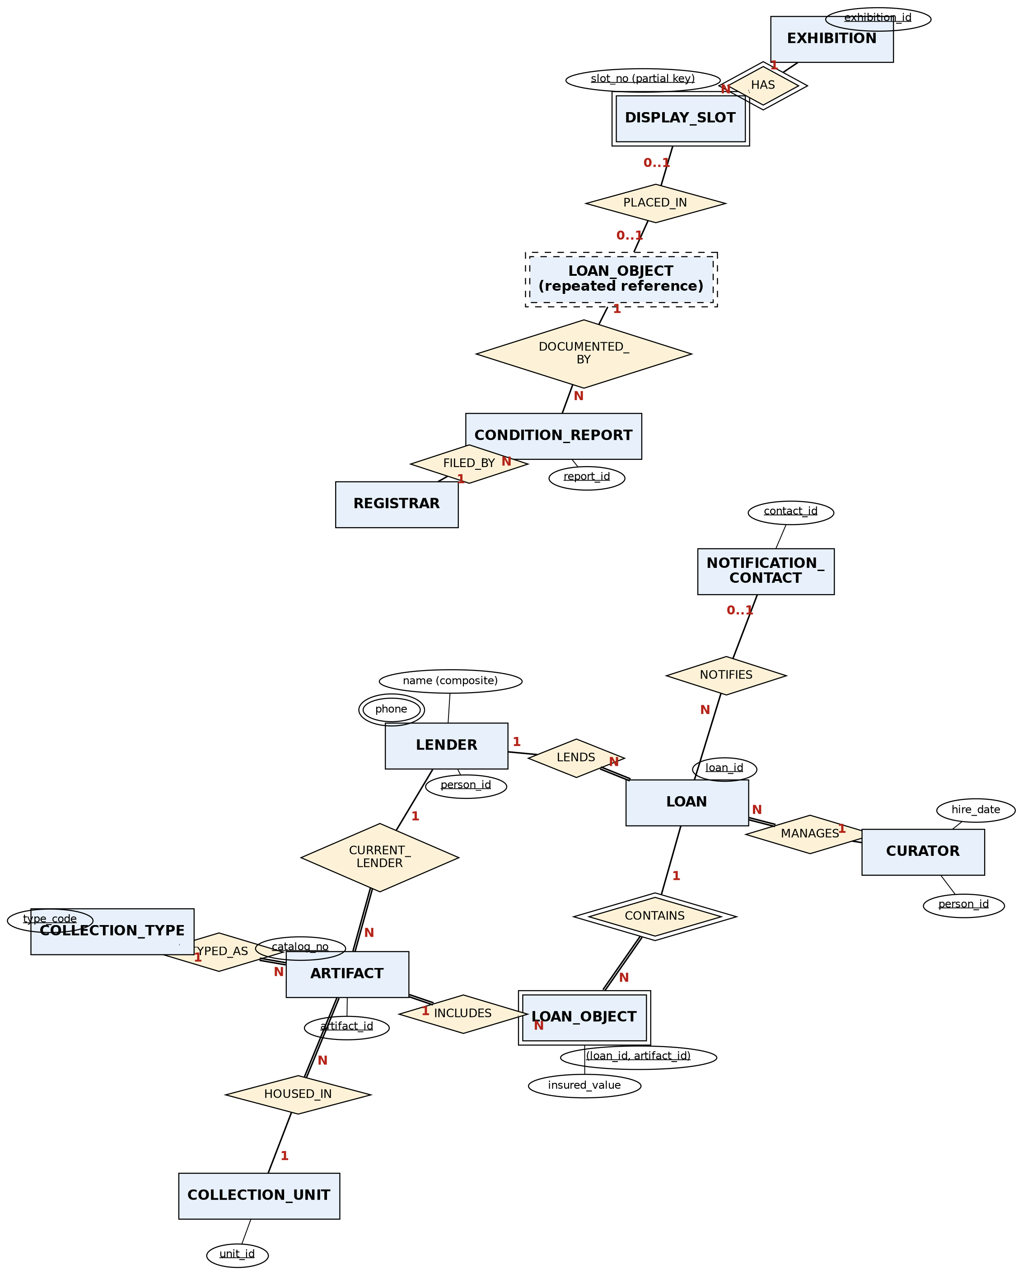
Figure 2 – Chen ER diagram of the loan coordination model (design C).

4.1 Legend and notation
Symbol | Meaning
Rectangle | Strong entity
Double rectangle | Weak entity (LOAN_OBJECT, DISPLAY_SLOT)
Dashed rectangle | Repeated reference to an entity already drawn (explained below)
Diamond / double diamond | Relationship / identifying relationship of a weak entity
Ellipse / double ellipse | Attribute / multivalued attribute (phone)
Underlined text | Primary key; for weak entities the partial key (slot_no) or owner-scoped key
Double line | Total (compulsory) participation
1, N, 0..1 | Cardinality / participation shown next to the entity it constrains
Lines that cross with no dot | Not connected

Repeated entity reference. LOAN_OBJECT is needed on three paths (to LOAN, to CONDITION_REPORT and to DISPLAY_SLOT). Drawing every line to one box would produce a tangle, so the box is drawn twice: the solid copy shows the identifying link to LOAN and ARTIFACT, and the dashed copy ‘(repeated reference)’ starts the condition-report and placement paths. Both boxes are the same entity with the same key (loan_id, artifact_id). This keeps the condition-evidence path readable: evidence hangs from the object-on-loan, never from the lender.

4.2 Identifying owner of DISPLAY_SLOT
DISPLAY_SLOT is a weak entity. Its identifying owner is EXHIBITION through the identifying relationship HAS (double diamond), and its owner-scoped key is (exhibition_id, slot_no); slot_no is only a partial key because numbering restarts in each exhibition.

4.3 Complete attribute catalogue
Entity | Attributes (key underlined in diagram; here marked PK) | Notes
PERSON | person_id (PK), given_name, middle_name, family_name, email (unique), phone (multivalued) | Supertype of LENDER and EMPLOYEE
LENDER | person_id (PK, FK), lender_since | Role of a PERSON
EMPLOYEE (CURATOR, REGISTRAR) | person_id (PK, FK), emp_role, unit_id, hire_date | emp_role is the discriminator
ORGANIZATION | org_id (PK), org_name, org_email
NOTIFICATION_CONTACT | contact_id (PK), person_id or org_id (exactly one) | Category/union
ARTIFACT | artifact_id (PK), catalog_no (unique), title, type_code, unit_id, lender_id, declared_value | lender_id = the one current lender
COLLECTION_TYPE | type_code (PK), type_name, handling_rule
COLLECTION_UNIT | unit_id (PK), unit_name | 8 units
LOAN | loan_id (PK), lender_id, curator_id, contact_id, loan_start, loan_expiry, returned_on, status
LOAN_OBJECT | (loan_id, artifact_id) (PK), insured_value | Weak/associative
EXHIBITION | exhibition_id (PK), exhibition_name, opens_on, closes_on | Name not unique
DISPLAY_SLOT | (exhibition_id, slot_no) (PK), gallery | Weak
PLACEMENT | (loan_id, artifact_id) (PK), exhibition_id, slot_no, placed_from, placed_to | Association; slot unique
CONDITION_REPORT | report_id (PK), loan_id, artifact_id, report_date, report_type, condition_grade, registrar_id | FK to LOAN_OBJECT

Consistency with Tasks 2 and 3: the keys in Figure 2 are those of the Task 2 catalogue, and every cardinality printed on the figure is the corresponding row of the Task 3 table (e.g. LENDS 1:N total on LOAN, DOCUMENTED_BY 1:N with min 0 on the object side).

Task 5 – Extend the Model to an EER Model [3 Marks]
QUESTION | TASK 5 – Extend the Model to an EER Model [3 Marks]
Use EER concepts to resolve overlapping roles and mixed contact identities in the Meridian Museum model. Handle a curator lending a personal collection.
Discuss:
• Generalize LENDER and employees into PERSON, then specialize employees into CURATOR and REGISTRAR.
• Decide whether role membership overlaps and whether the employee specialization covers all employees. Relate this to custody periods and condition evidence.
• Explain how the employee Role discriminator controls subtype membership. Illustrate this through custody periods and condition evidence.
• Represent a notification contact that can be either a person or an organization as a union category. Use the case issue of custody periods and condition evidence.
• Compare the subtype design with one wide record containing all LENDER, CURATOR and REGISTRAR fields.
Evidence Expected
A correct EER diagram with justified specialization constraints and use of aggregation/category.

ANSWER
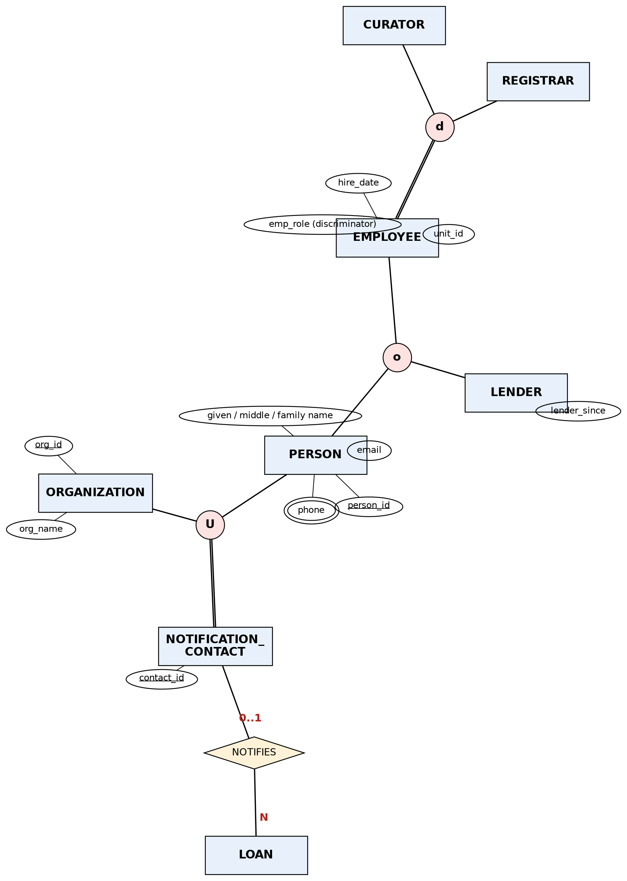
Figure 3 – EER diagram: PERSON generalisation, employee specialisation and the NOTIFICATION_CONTACT category.

5.1 Generalisation and specialisation
LENDER and employee were separate records in Alternatives A and B. In the EER model they are generalised into PERSON (person_id, name components, email, phones). EMPLOYEE is then specialised into CURATOR and REGISTRAR, because the two roles differ in duties (curators manage loans, registrars file condition reports) although they currently share all employee attributes.

5.2 Overlap and coverage
Constraint | Decision | Evidence and consequence for custody/evidence
LENDER vs EMPLOYEE | Overlapping (o) | A curator may lend a privately owned object. Query Q7 returns 3 such people at every size. If the two were disjoint, the curator’s private loan and the curator’s management of a loan would need two identities.
PERSON → {LENDER, EMPLOYEE} | Partial | A person may be a plain contact or notification person with neither role
EMPLOYEE → {CURATOR, REGISTRAR} | Disjoint (d) and total | Every employee is exactly one of the two; emp_role is NOT NULL. A registrar cannot be recorded as curator of a loan (needs a trigger, Task 8)

5.3 Discriminator
The employee attribute emp_role (values CURATOR, REGISTRAR) is a *predicate-defined discriminator*: it decides the subtype of each EMPLOYEE row. LOAN.curator_id must reference an employee whose emp_role is CURATOR, and CONDITION_REPORT.registrar_id one whose emp_role is REGISTRAR. This protects custody (who is responsible for a loan) and evidence (who attests the condition).

5.4 Notification contact as a union category
A loan’s notification contact can be a PERSON or an ORGANIZATION (e.g. a trust). NOTIFICATION_CONTACT is a category (union type U) of PERSON and ORGANIZATION: each contact is exactly one of them, enforced by CHECK ((person_id IS NULL) <> (org_id IS NULL)). The actual test in Task 8 shows both ‘both set’ and ‘neither set’ inserts are rejected.

5.5 Subtype design versus one wide record
A single wide table with all LENDER, CURATOR and REGISTRAR fields would need lender_since, emp_role, unit_id and hire_date on every row. In the 1,000-lender database (1,037 people) that is 3,028 NULL cells just to say ‘not applicable’, and the three overlapping curators would have to be duplicated or flagged. Role-specific constraints (a lender needs lender_since; an employee needs a unit) would have to be conditional CHECKs, and foreign keys could not point at ‘a curator’ or ‘a lender’ without pointing at everyone. Subtypes remove the NULLs and make each foreign key precise (LOAN.lender_id → LENDER, LOAN.curator_id → EMPLOYEE).

Task 6 – Model Weak Entities and Complex Attributes [3 Marks]
QUESTION | TASK 6 – Model Weak Entities and Complex Attributes [3 Marks]
Resolve owner-dependent identities and complex attributes in the Meridian Museum design. Distinguish an artifact value from a loan-line valuation.
Discuss:
• Show the owner and local key of DISPLAY_SLOT; distinguish identifying links from ordinary foreign keys.
• Map multiple telephone numbers into separate rows rather than comma-separated values. Illustrate this through custody periods and condition evidence.
• Separate name components and explain which custody periods and condition evidence summaries should be computed. Use the case issue of custody periods and condition evidence.
• Decide which coded concepts need entity identity because they have their own data or relationships. Relate this to custody periods and condition evidence.
Evidence Expected
Correct and justified treatment of weak entities and composite, multivalued and derived attributes.

ANSWER

6.1 DISPLAY_SLOT: owner and local key
Owner: EXHIBITION (identifying relationship HAS). Local (partial) key: slot_no. Full key: (exhibition_id, slot_no). An *identifying link* is part of the primary key and is deleted with its owner (ON DELETE CASCADE on fk_slot_exh); an ordinary foreign key such as ARTIFACT.lender_id is not part of the key and uses RESTRICT. In the generated data all 60 exhibitions of the 1,000-lender database reuse slot numbers 1–50, so slot_no on its own is demonstrably not unique.

6.2 Multivalued telephone numbers
A person may have several numbers, so they are stored as rows of PERSON_PHONE (person_id, phone_no, phone_type) with primary key (person_id, phone_no) rather than a comma-separated string. This matters for custody notifications: the loan desk can contact the lender on the number for the right purpose, and a contact can be looked up by number. The 1,000-lender database holds 2,069 phone rows for 1,037 people; the same lender’s numbers can be changed individually without touching loans or condition reports.

6.3 Name components and computed summaries
- Name is split into given_name, middle_name and family_name (composite attribute) so sorting, searching and de-duplication use the right part.
- Computed, not stored: artifact_count and total_insured per loan, days_overdue, loan length, the number of condition reports per object and the current ownership split. They are derived from LOAN_OBJECT, CONDITION_REPORT and ARTIFACT_OWNERSHIP in V_LOAN_SUMMARY and queries Q1–Q8, so an extension of a loan or a new report can never leave a stale summary.
- Not computed: loan_start, loan_expiry, returned_on, report_date – they are source facts and must be stored.

6.4 Coded concepts that need entity identity
Coded concept | Entity or plain attribute | Reason
CollectionType (PNT, SCU, TEX, MSS, CER, MET) | Entity COLLECTION_TYPE | Has its own data (type_name, handling_rule) and is referenced by ARTIFACT
Collection unit (8 units) | Entity COLLECTION_UNIT | Referenced by ARTIFACT and EMPLOYEE; has a name
Loan status | Attribute (ENUM) | No data of its own; four fixed values with workflow CHECKs
Report type (CHECK_IN / INSPECTION / CHECK_OUT) | Attribute (ENUM) | No own data; it only labels the examination
Phone type | Attribute (ENUM) | No own data

6.5 Artifact value versus loan-line valuation
ARTIFACT.declared_value is a property of the object; LOAN_OBJECT.insured_value is what this loan is insured for. They legitimately differ, and the same artifact has a different insured value on each successive loan (1,361 artifacts in the 1,000-lender data appear on more than one loan). Putting the insured value on ARTIFACT would overwrite the history of earlier loans, i.e. destroy custody evidence.

Task 7 – Map the EER Model to a Relational Schema [4 Marks]
QUESTION | TASK 7 – Map the EER Model to a Relational Schema [4 Marks]
Derive relations from the preferred Meridian Museum EER model and explain the mapping decisions. Map several artifacts within one loan.
Discuss:
• Trace strong entities, DISPLAY_SLOT, 1:1 and 1:N associations, M:N associations and multivalued contacts into relations.
• Choose among the standard specialization mapping options for the overlapping PERSON roles. Use the case issue of custody periods and condition evidence.
• Specify primary and foreign keys and defend deletion behaviour for historical LOAN records. Relate this to custody periods and condition evidence.
• Draw a schema catalog whose references agree with the implementation. Illustrate this through custody periods and condition evidence.
Evidence Expected
A complete relational schema derived step by step from the EER model with justified mapping options.

ANSWER

7.1 Step-by-step mapping from the EER model
Step | EER construct | Mapping decision | Resulting relation(s)
1 | Strong entities | One relation each; surrogate key as PK | PERSON, ORGANIZATION, ARTIFACT, LOAN, EXHIBITION, CONDITION_REPORT, COLLECTION_TYPE, COLLECTION_UNIT
2 | Weak entity DISPLAY_SLOT | Owner key + partial key as composite PK; FK to owner, ON DELETE CASCADE | DISPLAY_SLOT(exhibition_id, slot_no, gallery)
3 | Associative/weak LOAN_OBJECT | Composite PK of the two FKs plus its own attribute | LOAN_OBJECT(loan_id, artifact_id, insured_value)
4 | 1:N relationships | FK on the N side: LOAN.lender_id, LOAN.curator_id, LOAN.contact_id, ARTIFACT.lender_id, ARTIFACT.type_code, ARTIFACT.unit_id | –
5 | 1:1-like PLACED_IN (0..1 : 0..1) | Separate relation, with the slot unique, so that both sides may be absent without NULLs | PLACEMENT(loan_id, artifact_id, exhibition_id, slot_no, placed_from, placed_to)
6 | M:N ARTIFACT–LOAN | Resolved by LOAN_OBJECT (step 3) | –
7 | Multivalued phone | Separate relation, PK (person_id, phone_no) | PERSON_PHONE
8 | Specialisation of PERSON (overlapping) | Superclass + one relation per subclass sharing person_id (the ‘separate relation per subclass’ option) | PERSON, LENDER, EMPLOYEE
9 | Specialisation of EMPLOYEE (disjoint, total, no extra subclass attributes) | Single relation with discriminator emp_role | EMPLOYEE(…, emp_role)
10 | Category NOTIFICATION_CONTACT | Surrogate key plus one nullable FK per parent, with an exactly-one CHECK | NOTIFICATION_CONTACT(contact_id, person_id, org_id)

7.2 Choice among the specialisation mapping options
Option | Verdict for overlapping PERSON roles | Link to custody periods / condition evidence
Single relation with a type column | Rejected: one type value cannot say ‘lender and curator’ for the same person | A curator’s private loan would require a duplicate PERSON row, splitting that person’s custody history
Single relation with Boolean flags per role | Rejected: allowed overlap but produces mostly-NULL role columns and no precise foreign keys (see Task 5.5) | LOAN.curator_id could reference a non-curator
Relation per concrete subclass only (no superclass) | Rejected: overlapping people would be stored twice | Evidence filed by registrar identity would diverge between copies
Superclass relation + one relation per role (chosen) | Accepted: one identity, role tables with role-specific keys | LOAN.lender_id references LENDER; LOAN.curator_id references EMPLOYEE; REGISTRAR attests CONDITION_REPORT; all trace to the same person_id

7.3 Schema catalogue (primary keys, foreign keys, deletion behaviour)
Relation | Primary key | Foreign keys → target (on delete)
PERSON | person_id | –
PERSON_PHONE | (person_id, phone_no) | person_id → PERSON (CASCADE)
LENDER | person_id | person_id → PERSON (RESTRICT)
EMPLOYEE | person_id | person_id → PERSON; unit_id → COLLECTION_UNIT (RESTRICT)
ORGANIZATION | org_id | –
NOTIFICATION_CONTACT | contact_id | person_id → PERSON; org_id → ORGANIZATION (RESTRICT)
COLLECTION_UNIT / COLLECTION_TYPE | unit_id / type_code | –
ARTIFACT | artifact_id (catalog_no unique) | type_code, unit_id, lender_id → LENDER (RESTRICT)
LOAN | loan_id | lender_id → LENDER; curator_id → EMPLOYEE; contact_id → NOTIFICATION_CONTACT (RESTRICT)
LOAN_OBJECT | (loan_id, artifact_id) | loan_id → LOAN; artifact_id → ARTIFACT (RESTRICT)
EXHIBITION | exhibition_id | –
DISPLAY_SLOT | (exhibition_id, slot_no) | exhibition_id → EXHIBITION (CASCADE – identifying link)
PLACEMENT | (loan_id, artifact_id) | (loan_id, artifact_id) → LOAN_OBJECT; (exhibition_id, slot_no) → DISPLAY_SLOT (RESTRICT); UNIQUE (exhibition_id, slot_no)
CONDITION_REPORT | report_id | (loan_id, artifact_id) → LOAN_OBJECT; registrar_id → EMPLOYEE (RESTRICT)

Deletion behaviour for historical records. Everything that records what happened (LOAN, LOAN_OBJECT, CONDITION_REPORT, PLACEMENT, and the LENDER/ARTIFACT/EMPLOYEE they point to) uses RESTRICT, so a lender, artifact or loan with history cannot be deleted by accident; the actual attempts in Task 8 are refused with error 1451. Only owner-dependent detail with no independent history (phone numbers, and display slots of an exhibition that was never used) cascades. Loans end by changing status (RETURNED / CANCELLED), never by deletion, which keeps custody periods and condition evidence permanent.
Placement-to-slot composite constraint. PLACEMENT carries (exhibition_id, slot_no) and a *composite* foreign key to DISPLAY_SLOT, so a placement cannot refer to a slot number that does not exist in that exhibition. A second composite FK to LOAN_OBJECT guarantees the object was really on that loan. The schema catalogue above agrees column-for-column with the DDL in Task 8 (the same file produced Figure 2 and the tables).

Task 8 – Implement the Schema and Populate Instances [4 Marks]
QUESTION | TASK 8 – Implement the Schema and Populate Instances [4 Marks]
Implement the Meridian Museum relations in MySQL and construct reproducible valid states for four workload sizes. Check loan-period validity at the row level.
Scale the generated client population through: Relate this to custody periods and condition evidence.
100, 1,000, 10,000 and 100,000 lender records, with proportionate operational evidence. Illustrate this through custody periods and condition evidence.
Ensure that:
• Create the relations and constraints derived for loan coordination.
• Use seed 4211 and document how source keys are selected when generating linked rows. Illustrate this through custody periods and condition evidence.
• Show one stable schema with several changing LENDER and LOAN instances. Use the case issue of custody periods and condition evidence.
• Attempt invalid identity, workflow and category writes and retain the actual failure messages. Relate this to custody periods and condition evidence.
• Identify business rules that need more than a row-level CHECK constraint. Illustrate this through custody periods and condition evidence.
Evidence Expected
Working DDL and data-generation scripts with a clearly described, reproducible loading procedure.

ANSWER

8.1 DDL (MySQL/InnoDB) – relations and constraints
-- Meridian Museum loan coordination: preferred design (Alternative C) -- MySQL/MariaDB InnoDB
SET FOREIGN_KEY_CHECKS=0;
DROP TABLE IF EXISTS condition_report, placement, display_slot, exhibition, loan_object, loan,
artifact, notification_contact, organization, employee, lender, person_phone, person,
collection_type, collection_unit;
SET FOREIGN_KEY_CHECKS=1;

CREATE TABLE collection_unit (
unit_id TINYINT UNSIGNED PRIMARY KEY,
unit_name VARCHAR(60) NOT NULL UNIQUE
) ENGINE=InnoDB;

CREATE TABLE collection_type (
type_code CHAR(3) PRIMARY KEY,
type_name VARCHAR(40) NOT NULL,
handling_rule VARCHAR(100) NOT NULL
) ENGINE=InnoDB;

CREATE TABLE person (
person_id INT UNSIGNED AUTO_INCREMENT PRIMARY KEY,
given_name VARCHAR(40) NOT NULL,
middle_name VARCHAR(40) NULL,
family_name VARCHAR(40) NOT NULL,
email VARCHAR(90) NOT NULL UNIQUE
) ENGINE=InnoDB;

CREATE TABLE person_phone (
person_id INT UNSIGNED NOT NULL,
phone_no VARCHAR(20) NOT NULL,
phone_type ENUM('MOBILE','OFFICE','HOME') NOT NULL,
PRIMARY KEY (person_id, phone_no),
CONSTRAINT fk_phone_person FOREIGN KEY (person_id) REFERENCES person(person_id) ON DELETE CASCADE
) ENGINE=InnoDB;

CREATE TABLE lender (
person_id INT UNSIGNED PRIMARY KEY,
lender_since DATE NOT NULL,
CONSTRAINT fk_lender_person FOREIGN KEY (person_id) REFERENCES person(person_id)
) ENGINE=InnoDB;

CREATE TABLE employee (
person_id INT UNSIGNED PRIMARY KEY,
emp_role ENUM('CURATOR','REGISTRAR') NOT NULL,
unit_id TINYINT UNSIGNED NOT NULL,
hire_date DATE NOT NULL,
CONSTRAINT fk_emp_person FOREIGN KEY (person_id) REFERENCES person(person_id),
CONSTRAINT fk_emp_unit FOREIGN KEY (unit_id) REFERENCES collection_unit(unit_id)
) ENGINE=InnoDB;

CREATE TABLE organization (
org_id INT UNSIGNED AUTO_INCREMENT PRIMARY KEY,
org_name VARCHAR(90) NOT NULL,
org_email VARCHAR(90) NOT NULL
) ENGINE=InnoDB;

-- EER "category" (union of PERSON and ORGANIZATION): exactly one parent per contact
CREATE TABLE notification_contact (
contact_id INT UNSIGNED AUTO_INCREMENT PRIMARY KEY,
person_id INT UNSIGNED NULL,
org_id INT UNSIGNED NULL,
CONSTRAINT fk_nc_person FOREIGN KEY (person_id) REFERENCES person(person_id),
CONSTRAINT fk_nc_org FOREIGN KEY (org_id) REFERENCES organization(org_id),
CONSTRAINT ck_nc_exactly_one CHECK ((person_id IS NULL) <> (org_id IS NULL))
) ENGINE=InnoDB;

CREATE TABLE artifact (
artifact_id INT UNSIGNED AUTO_INCREMENT PRIMARY KEY,
catalog_no VARCHAR(12) NOT NULL UNIQUE,
title VARCHAR(120) NOT NULL,
type_code CHAR(3) NOT NULL,
unit_id TINYINT UNSIGNED NOT NULL,
lender_id INT UNSIGNED NOT NULL, -- the ONE current lender of record
declared_value DECIMAL(12,2) NOT NULL,
CONSTRAINT ck_art_value CHECK (declared_value >= 0),
CONSTRAINT fk_art_type FOREIGN KEY (type_code) REFERENCES collection_type(type_code),
CONSTRAINT fk_art_unit FOREIGN KEY (unit_id) REFERENCES collection_unit(unit_id),
CONSTRAINT fk_art_lender FOREIGN KEY (lender_id) REFERENCES lender(person_id)
) ENGINE=InnoDB;

CREATE TABLE loan (
loan_id INT UNSIGNED AUTO_INCREMENT PRIMARY KEY,
lender_id INT UNSIGNED NOT NULL,
curator_id INT UNSIGNED NOT NULL,
contact_id INT UNSIGNED NULL,
loan_start DATE NOT NULL,
loan_expiry DATE NOT NULL,
returned_on DATE NULL,
status ENUM('REQUESTED','ACTIVE','RETURNED','CANCELLED') NOT NULL,
CONSTRAINT ck_loan_period CHECK (loan_expiry > loan_start),
CONSTRAINT ck_loan_return CHECK (returned_on IS NULL OR returned_on >= loan_start),
CONSTRAINT ck_loan_status CHECK ((status = 'RETURNED') = (returned_on IS NOT NULL)),
CONSTRAINT fk_loan_lender FOREIGN KEY (lender_id) REFERENCES lender(person_id),
CONSTRAINT fk_loan_curator FOREIGN KEY (curator_id) REFERENCES employee(person_id),
CONSTRAINT fk_loan_contact FOREIGN KEY (contact_id) REFERENCES notification_contact(contact_id)
) ENGINE=InnoDB;
CREATE INDEX ix_loan_lender ON loan(lender_id);
CREATE INDEX ix_loan_status_expiry ON loan(status, loan_expiry);

CREATE TABLE loan_object (
loan_id INT UNSIGNED NOT NULL,
artifact_id INT UNSIGNED NOT NULL,
insured_value DECIMAL(12,2) NOT NULL, -- loan-line valuation, NOT the artifact value
PRIMARY KEY (loan_id, artifact_id),
CONSTRAINT ck_lo_value CHECK (insured_value >= 0),
CONSTRAINT fk_lo_loan FOREIGN KEY (loan_id) REFERENCES loan(loan_id),
CONSTRAINT fk_lo_artifact FOREIGN KEY (artifact_id) REFERENCES artifact(artifact_id)
) ENGINE=InnoDB;
CREATE INDEX ix_lo_artifact ON loan_object(artifact_id);

CREATE TABLE exhibition (
exhibition_id INT UNSIGNED AUTO_INCREMENT PRIMARY KEY,
exhibition_name VARCHAR(100) NOT NULL, -- deliberately NOT unique
opens_on DATE NOT NULL,
closes_on DATE NOT NULL,
CONSTRAINT ck_exh_period CHECK (closes_on > opens_on)
) ENGINE=InnoDB;

-- weak entity: identified by (exhibition_id, slot_no)
CREATE TABLE display_slot (
exhibition_id INT UNSIGNED NOT NULL,
slot_no SMALLINT UNSIGNED NOT NULL,
gallery VARCHAR(30) NOT NULL,
PRIMARY KEY (exhibition_id, slot_no),
CONSTRAINT fk_slot_exh FOREIGN KEY (exhibition_id) REFERENCES exhibition(exhibition_id) ON DELETE CASCADE
) ENGINE=InnoDB;

CREATE TABLE placement (
loan_id INT UNSIGNED NOT NULL,
artifact_id INT UNSIGNED NOT NULL,
exhibition_id INT UNSIGNED NOT NULL,
slot_no SMALLINT UNSIGNED NOT NULL,
placed_from DATE NOT NULL,
placed_to DATE NOT NULL,
PRIMARY KEY (loan_id, artifact_id),
UNIQUE KEY uq_slot_once (exhibition_id, slot_no),
CONSTRAINT ck_pl_period CHECK (placed_to >= placed_from),
CONSTRAINT fk_pl_lo FOREIGN KEY (loan_id, artifact_id) REFERENCES loan_object(loan_id, artifact_id),
CONSTRAINT fk_pl_slot FOREIGN KEY (exhibition_id, slot_no) REFERENCES display_slot(exhibition_id, slot_no)
) ENGINE=InnoDB;

CREATE TABLE condition_report (
report_id INT UNSIGNED AUTO_INCREMENT PRIMARY KEY,
loan_id INT UNSIGNED NOT NULL,
artifact_id INT UNSIGNED NOT NULL,
report_date DATE NOT NULL,
report_type ENUM('CHECK_IN','INSPECTION','CHECK_OUT') NOT NULL,
condition_grade TINYINT NOT NULL,
registrar_id INT UNSIGNED NOT NULL,
CONSTRAINT ck_cr_grade CHECK (condition_grade BETWEEN 1 AND 5),
CONSTRAINT fk_cr_lo FOREIGN KEY (loan_id, artifact_id) REFERENCES loan_object(loan_id, artifact_id),
CONSTRAINT fk_cr_reg FOREIGN KEY (registrar_id) REFERENCES employee(person_id)
) ENGINE=InnoDB;
CREATE INDEX ix_cr_lo ON condition_report(loan_id, artifact_id);

CREATE OR REPLACE VIEW v_loan_summary AS
SELECT l.loan_id, CONCAT(p.given_name,' ',p.family_name) AS lender_name, l.loan_start, l.loan_expiry,
l.status, COUNT(lo.artifact_id) AS artifact_count, SUM(lo.insured_value) AS total_insured
FROM loan l JOIN person p ON p.person_id = l.lender_id
LEFT JOIN loan_object lo ON lo.loan_id = l.loan_id
GROUP BY l.loan_id, p.given_name, p.family_name, l.loan_start, l.loan_expiry, l.status;

8.2 Reproducible generation procedure and seed
- Generator: gen.py (Appendix A), Python 3, seed 4211 (the random stream for a size N is random.Random(4211 + N), so each size is reproducible and the four populations are independent).
- Run: python3 gen.py N writes CSV files to /tmp/gen/N, then ./load.sh N creates database meridian_N, runs schema.sql and loads the CSVs with LOAD DATA INFILE in dependency order (units/types, persons, phones, lenders, employees, organisations, contacts, artifacts, loans, loan lines, exhibitions, slots, placements, reports) with foreign-key checking on.
- How source keys are chosen for linked rows: parents are generated first and children sample from the parents’ real id lists. Artifacts are assigned to a lender; a loan picks 1–5 artifacts only from its own lender’s artifacts (r.sample(owned[lender])); loan periods for one lender are laid out one after another with 10–60 day gaps, so a given artifact never lies in two overlapping loans; curators are sampled from ids 1–35 and registrars from 36–40; condition reports exist only for lines of ACTIVE/RETURNED loans and use (loan_id, artifact_id) copied from the line; placements consume slots 1–50 of each exhibition in order, so (exhibition, slot) is never repeated.
- Dates: ‘today’ is 2026-11-01. About 4% of loans whose expiry has passed are left ACTIVE (overdue, never closed); about 2% are CANCELLED; loans starting after today are REQUESTED.

8.3 Four workload sizes (actual row counts)
Relation | 100 lenders | 1,000 lenders | 10,000 lenders | 100,000 lenders
PERSON | 137 | 1,037 | 10,037 | 100,037
PERSON_PHONE | 258 | 2,069 | 19,996 | 200,145
LENDER | 100 | 1,000 | 10,000 | 100,000
EMPLOYEE | 40 | 40 | 40 | 40
ORGANIZATION | 10 | 55 | 505 | 5,005
NOTIFICATION_CONTACT | 13 | 227 | 2,000 | 20,262
ARTIFACT | 742 | 7,656 | 74,828 | 750,870
LOAN | 218 | 2,011 | 19,946 | 200,252
LOAN_OBJECT | 667 | 6,020 | 58,400 | 584,295
CONDITION_REPORT | 1,047 | 9,690 | 94,714 | 945,371
EXHIBITION | 8 | 60 | 577 | 5,729
DISPLAY_SLOT | 400 | 3,000 | 28,850 | 286,450
PLACEMENT | 312 | 2,926 | 28,764 | 286,355

One stable schema, several changing instances. The same schema.sql produced all four databases (meridian_100 … meridian_100000); only the instances change. The population grows roughly linearly (about 7.5 artifacts, 2 loans, 6 loan lines and 9.5 condition reports per lender) while the 8 collection units, 6 collection types and 40 employees stay fixed, exactly as the case describes.

8.4 Invalid identity, workflow and category writes (actual failure messages)
Attempt | Statement (shortened) | Actual result from the server
Duplicate catalog number (identity) | INSERT INTO artifact(catalog_no,title,type_code,unit_id,lender_id,declared_value) VALUES ('MM-0000001','Duplic… | ERROR 1062: Duplicate entry 'MM-0000001' for key 'catalog_no'
Loan expiring before it starts (workflow) | INSERT INTO loan(lender_id,curator_id,loan_start,loan_expiry,status) VALUES (41,1,'2026-05-10','2026-05-01','A… | ERROR 4025: CONSTRAINT ck_loan_period failed for meridian_1000.loan
Status outside the allowed list (category) | INSERT INTO loan(lender_id,curator_id,loan_start,loan_expiry,status) VALUES (41,1,'2026-05-01','2026-06-01','L… | ERROR 1265: Data truncated for column 'status' at row 1
RETURNED loan without a return date (workflow) | INSERT INTO loan(lender_id,curator_id,loan_start,loan_expiry,status) VALUES (41,1,'2026-05-01','2026-06-01','R… | ERROR 4025: CONSTRAINT ck_loan_status failed for meridian_1000.loan
Contact that is both person and organization (category) | INSERT INTO notification_contact(person_id,org_id) VALUES (5,1) | ERROR 4025: CONSTRAINT ck_nc_exactly_one failed for meridian_1000.notification_contact
Contact that is neither person nor organization (category) | INSERT INTO notification_contact(person_id,org_id) VALUES (NULL,NULL) | ERROR 4025: CONSTRAINT ck_nc_exactly_one failed for meridian_1000.notification_contact
Placement into a slot that does not exist (identity) | INSERT INTO placement VALUES (2,13,1,99,'2026-01-01','2026-02-01') | ERROR 1452: Cannot add or update a child row: a foreign key constraint fails (meridian_1000.placement, CONSTRAINT fk_pl_slot FOREIGN KEY (exhibition_id, slot_no) REFERENCES display_slot (exhibition_id, slot_no))
Placement of an object that is not on the loan (identity) | INSERT INTO placement VALUES (1,999999,1,1,'2026-01-01','2026-02-01') | ERROR 1452: Cannot add or update a child row: a foreign key constraint fails (meridian_1000.placement, CONSTRAINT fk_pl_lo FOREIGN KEY (loan_id, artifact_id) REFERENCES loan_object (loan_id, artifact_id))
Second object into an occupied slot (identity) | INSERT INTO placement VALUES (2,13,1,1,'2026-01-01','2026-02-01') | ERROR 1062: Duplicate entry '1-1' for key 'uq_slot_once'
Condition grade outside 1-5 | INSERT INTO condition_report(loan_id,artifact_id,report_date,report_type,condition_grade,registrar_id) VALUES … | ERROR 4025: CONSTRAINT ck_cr_grade failed for meridian_1000.condition_report
Report for artifact not on that loan (evidence ownership) | INSERT INTO condition_report(loan_id,artifact_id,report_date,report_type,condition_grade,registrar_id) VALUES … | ERROR 1452: Cannot add or update a child row: a foreign key constraint fails (meridian_1000.condition_report, CONSTRAINT fk_cr_lo FOREIGN KEY (loan_id, artifact_id) REFERENCES loan_object (loan_id, artifact_id))
Delete a lender who has historical loans | DELETE FROM lender WHERE person_id=1 | ERROR 1451: Cannot delete or update a parent row: a foreign key constraint fails (meridian_1000.artifact, CONSTRAINT fk_art_lender FOREIGN KEY (lender_id) REFERENCES lender (person_id))
Delete a loan that has loan lines | DELETE FROM loan WHERE loan_id=1 | ERROR 1451: Cannot delete or update a parent row: a foreign key constraint fails (meridian_1000.loan_object, CONSTRAINT fk_lo_loan FOREIGN KEY (loan_id) REFERENCES loan (loan_id))

All thirteen statements were rejected. Errors 1062 (duplicate key) and 1452/1451 (foreign-key) cover identity; 4025 (CHECK) covers workflow rules and the person-or-organisation category; 1265 shows the status ENUM refusing an unlisted value.

8.5 Business rules that need more than a row-level CHECK
Two rules involve other rows or other tables, so a CHECK cannot express them. Both were accepted silently by the schema until triggers were added:
Rule | Without trigger (actual) | With trigger (actual)
LOAN.curator_id must be an employee whose role is CURATOR | ACCEPTED (no error) - loan_id 2012 (loan to registrar 36 was stored) | ERROR 1644: curator_id must reference an employee with role CURATOR
An artifact cannot be on two loans with overlapping periods | ACCEPTED (no error); the overlap check then found 1 overlapping pair(s) | ERROR 1644: artifact already on a loan overlapping this period

CREATE TRIGGER trg_loan_curator_role BEFORE INSERT ON loan FOR EACH ROW
BEGIN
IF (SELECT emp_role FROM employee WHERE person_id = NEW.curator_id) <> 'CURATOR' THEN
SIGNAL SQLSTATE '45000' SET MESSAGE_TEXT = 'curator_id must reference an employee with role CURATOR';
END IF;
END
CREATE TRIGGER trg_loan_object_no_overlap BEFORE INSERT ON loan_object FOR EACH ROW
BEGIN
IF EXISTS (SELECT 1 FROM loan_object lo JOIN loan l ON l.loan_id = lo.loan_id
JOIN loan nl ON nl.loan_id = NEW.loan_id
WHERE lo.artifact_id = NEW.artifact_id AND l.status <> 'CANCELLED' AND nl.status <> 'CANCELLED'
AND l.loan_start <= nl.loan_expiry AND nl.loan_start <= l.loan_expiry) THEN
SIGNAL SQLSTATE '45000' SET MESSAGE_TEXT = 'artifact already on a loan overlapping this period';
END IF;
END

Other cross-table rules still outside CHECK: a loan needs at least one LOAN_OBJECT once ACTIVE; a placement must lie within its loan’s period and the exhibition’s dates (Q6 audits this); report_date must lie within the loan period; ownership shares must total 100% (Task 12). These are enforced by triggers, application workflow or audit queries.

Task 9 – Validate the Design with Use-Case Queries [3 Marks]
QUESTION | TASK 9 – Validate the Design with Use-Case Queries [3 Marks]
Test whether the preferred model can answer operational questions about custody periods and condition evidence. Find artifacts that have no recorded condition evidence.
Record:
• Execute eight queries, including overdue loans still open and artifacts without condition evidence.
• Display SQL and actual output records, including empty results where no row meets a condition. Use the case issue of custody periods and condition evidence.
• Record result counts, explicit JOIN counts and median elapsed time for all four population sizes. Relate this to custody periods and condition evidence.
• Use a flat LOAN file to demonstrate insertion, update and deletion anomalies. Illustrate this through custody periods and condition evidence.
Evidence Expected
Systematically collected validation results presented in tables and/or graphs.

ANSWER

9.1 The eight queries – SQL and actual output
Each query below was executed on the 1,000-lender database (first five rows shown; the full result size at every population is in Table 9.2). Reference date: 2026-11-01.

Q1 Overdue loans still open
SELECT l.loan_id, CONCAT(p.given_name,' ',p.family_name) AS lender, l.loan_start, l.loan_expiry, DATEDIFF('2026-11-01',l.loan_expiry) AS days_overdue
FROM loan l JOIN person p ON p.person_id=l.lender_id
WHERE l.status='ACTIVE' AND l.loan_expiry < '2026-11-01' ORDER BY days_overdue DESC

loan_id | lender | loan_start | loan_expiry | days_overdue
957 | Kavya Iyer | 2022-02-12 | 2022-05-11 | 1635
1295 | Anika Menon | 2022-02-14 | 2022-06-23 | 1592
802 | Divya Khan | 2022-02-22 | 2022-07-14 | 1571
79 | Meera Iyer | 2022-03-16 | 2022-07-19 | 1566
261 | Anika Reddy | 2022-01-05 | 2022-09-22 | 1501

Rows returned: 91 at 1,000 lenders.

Q2 Loaned artifacts with no condition evidence
SELECT DISTINCT a.artifact_id, a.catalog_no, a.title
FROM artifact a JOIN loan_object lo ON lo.artifact_id=a.artifact_id JOIN loan l ON l.loan_id=lo.loan_id
WHERE l.status IN ('ACTIVE','RETURNED')
AND NOT EXISTS (SELECT 1 FROM condition_report cr WHERE cr.artifact_id=a.artifact_id) ORDER BY a.artifact_id

artifact_id | catalog_no | title
55 | MM-0000055 | Temple Lamp (c. 1294)
142 | MM-0000142 | Terracotta Horse (c. 939)
149 | MM-0000149 | Temple Lamp (c. 1465)
171 | MM-0000171 | Coin Hoard (c. 1031)
249 | MM-0000249 | Miniature Painting (c. 1408)

Rows returned: 120 at 1,000 lenders.

Q3 Loans carrying four or more artifacts
SELECT loan_id, lender_name, status, artifact_count, total_insured FROM v_loan_summary
WHERE artifact_count>=4 ORDER BY artifact_count DESC, total_insured DESC

loan_id | lender_name | status | artifact_count | total_insured
553 | Rohan Bose | RETURNED | 5 | 1040725.68
310 | Leela Joshi | RETURNED | 5 | 1016992.92
374 | Sana Joshi | RETURNED | 5 | 1003833.71
228 | Karthik Rao | RETURNED | 5 | 989362.94
361 | Ishita Sharma | RETURNED | 5 | 977944.15

Rows returned: 800 at 1,000 lenders.

Q4 Inventory of exhibition 1 through placements
SELECT ds.slot_no, ds.gallery, a.catalog_no, a.title, pl.placed_from, pl.placed_to
FROM display_slot ds JOIN placement pl ON pl.exhibition_id=ds.exhibition_id AND pl.slot_no=ds.slot_no
JOIN artifact a ON a.artifact_id=pl.artifact_id WHERE ds.exhibition_id=1 ORDER BY ds.slot_no

slot_no | gallery | catalog_no | title | placed_from | placed_to
1 | Gallery C | MM-0000010 | Stone Relief (c. 1122) | 2025-05-02 | 2025-06-02
2 | Gallery C | MM-0000003 | Silk Textile (c. 1487) | 2025-04-27 | 2025-08-13
3 | Gallery E | MM-0000014 | Palm-Leaf Manuscript (c. 1021) | 2023-05-15 | 2023-09-22
4 | Gallery D | MM-0000013 | Bronze Figurine (c. 1300) | 2024-03-04 | 2024-05-19
5 | Gallery B | MM-0000014 | Palm-Leaf Manuscript (c. 1021) | 2024-03-07 | 2024-05-02

Rows returned: 50 at 1,000 lenders.

Q5 Active loans expiring in next 90 days
SELECT l.loan_id, l.lender_id, l.loan_expiry, DATEDIFF(l.loan_expiry,'2026-11-01') AS days_left
FROM loan l WHERE l.status='ACTIVE' AND l.loan_expiry BETWEEN '2026-11-01' AND DATE_ADD('2026-11-01',INTERVAL 90 DAY)
ORDER BY l.loan_expiry

loan_id | lender_id | loan_expiry | days_left
1486 | 773 | 2026-11-02 | 1
1821 | 937 | 2026-11-02 | 1
1397 | 729 | 2026-11-10 | 9
1489 | 774 | 2026-11-14 | 13
1364 | 714 | 2026-11-16 | 15

Rows returned: 31 at 1,000 lenders.

Q6 Placements outside their loan period
SELECT pl.loan_id, pl.artifact_id, pl.placed_from, pl.placed_to, l.loan_start, l.loan_expiry
FROM placement pl JOIN loan l ON l.loan_id=pl.loan_id
WHERE pl.placed_from < l.loan_start OR pl.placed_to > l.loan_expiry

Empty result – 0 rows (no row meets the condition), which is the expected outcome for this integrity audit.
Rows returned: 0 at 1,000 lenders.

Q7 Curators who are also lenders
SELECT e.person_id, CONCAT(p.given_name,' ',p.family_name) AS name, e.emp_role, COUNT(DISTINCT a.artifact_id) AS artifacts_lent
FROM employee e JOIN lender ld ON ld.person_id=e.person_id JOIN person p ON p.person_id=e.person_id
LEFT JOIN artifact a ON a.lender_id=ld.person_id WHERE e.emp_role='CURATOR' GROUP BY e.person_id,p.given_name,p.family_name,e.emp_role

person_id | name | emp_role | artifacts_lent
1 | Aarav Shah | CURATOR | 12
2 | Sana Kapoor | CURATOR | 4
3 | Dev Gupta | CURATOR | 8

Rows returned: 3 at 1,000 lenders.

Q8 Artifacts in two overlapping loans
SELECT lo1.artifact_id, lo1.loan_id AS loan_a, lo2.loan_id AS loan_b
FROM loan_object lo1 JOIN loan l1 ON l1.loan_id=lo1.loan_id
JOIN loan_object lo2 ON lo2.artifact_id=lo1.artifact_id AND lo2.loan_id>lo1.loan_id
JOIN loan l2 ON l2.loan_id=lo2.loan_id
WHERE l1.status<>'CANCELLED' AND l2.status<>'CANCELLED' AND l1.loan_start<=l2.loan_expiry AND l2.loan_start<=l1.loan_expiry

Empty result – 0 rows (no row meets the condition), which is the expected outcome for this integrity audit.
Rows returned: 0 at 1,000 lenders.

9.2 Result counts, explicit JOIN counts and median elapsed time (all four sizes)
Query | 100 lenders | 1,000 lenders | 10,000 lenders | 100,000 lenders
Q1 Overdue loans still open | 8 | 91 | 747 | 7,480
Q2 Loaned artifacts with no condition evidence | 13 | 120 | 1,295 | 13,389
Q3 Loans carrying four or more artifacts | 90 | 800 | 7,303 | 71,950
Q4 Inventory of exhibition 1 through placements | 50 | 50 | 50 | 50
Q5 Active loans expiring in next 90 days | 3 | 31 | 240 | 2,444
Q6 Placements outside their loan period | 0 | 0 | 0 | 0
Q7 Curators who are also lenders | 3 | 3 | 3 | 3
Q8 Artifacts in two overlapping loans | 0 | 0 | 0 | 0

Table 9.2a – result counts (rows returned). Q6 and Q8 return 0 at every size, confirming that generated placements lie inside their loans and that no artifact is on overlapping loans.
Explicit JOIN (count of joined rows) | 100 | 1,000 | 10,000 | 100,000
person JOIN lender | 100 | 1,000 | 10,000 | 100,000
loan JOIN loan_object | 667 | 6,020 | 58,400 | 584,295
loan_object JOIN condition_report | 1,047 | 9,690 | 94,714 | 945,371
loan_object JOIN placement | 312 | 2,926 | 28,764 | 286,355
placement JOIN display_slot | 312 | 2,926 | 28,764 | 286,355

Table 9.2b – explicit JOIN counts. Each join equals the row count of its child relation (e.g. loan ⋈ loan_object = loan_object, condition_report = loan_object ⋈ condition_report), so no join fans out or drops rows: the keys and foreign keys line up.
Median elapsed time (ms, 5 runs) | 100 | 1,000 | 10,000 | 100,000
Q1 Overdue loans still open | 0.27 | 1.06 | 5.86 | 107.53
Q2 Loaned artifacts with no condition evidence | 1.00 | 7.55 | 79.37 | 1784.08
Q3 Loans carrying four or more artifacts | 1.75 | 15.03 | 189.78 | 9513.61
Q4 Inventory of exhibition 1 through placements | 0.60 | 0.79 | 0.82 | 1.19
Q5 Active loans expiring in next 90 days | 0.15 | 0.36 | 1.75 | 15.56
Q6 Placements outside their loan period | 0.32 | 2.36 | 36.91 | 285.19
Q7 Curators who are also lenders | 0.21 | 0.31 | 0.45 | 0.28
Q8 Artifacts in two overlapping loans | 1.08 | 8.96 | 93.61 | 949.27

Table 9.2c – median elapsed time. Timings were measured on the sandbox server and are only comparable with each other.
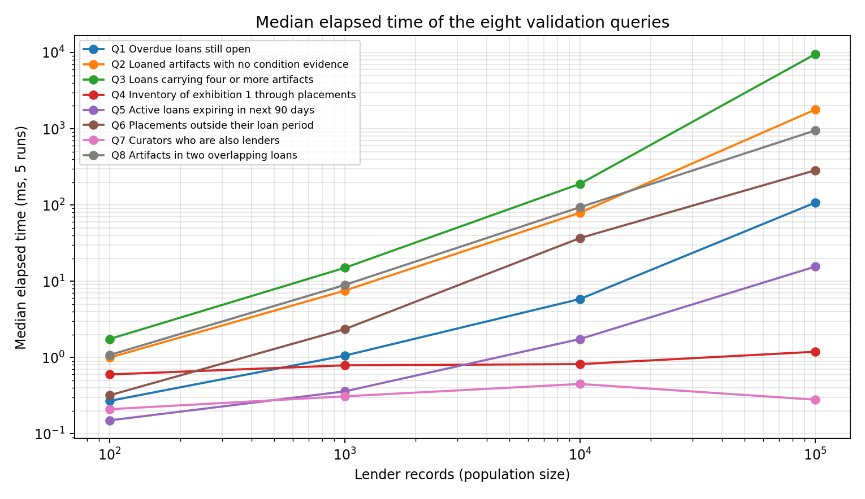
Figure 4 – Median query time against population size (log–log).
Reading the graph. Q4 (one exhibition, found by primary key) and Q7 (curators who lend) are almost flat – they use the clustered primary key. Q1 and Q5 grow roughly with the number of loans because ix_loan_status_expiry narrows to ACTIVE loans. Q2, Q3 and Q8 grow fastest: Q3 aggregates every loan through V_LOAN_SUMMARY and Q2/Q8 join and probe all loan lines (an index on loan_object(artifact_id) is what keeps Q8 at about 94 ms for 10,000 lenders and 949 ms for 100,000).

9.3 Flat LOAN file: insertion, update and deletion anomalies (actual runs)
A flat file FLAT_LOAN was built from the 1,000-lender data by joining loan, lender, artifact and loan line into one table (6,020 rows; one row per artifact per loan, repeating lender name/email and artifact title on every row).
Anomaly | Action | Actual result
Insertion | Record a newly catalogued artifact that has not been lent yet (loan columns empty) | ERROR 1048: Column 'loan_id' cannot be null – the artifact cannot exist until it is on a loan. In the normalised schema the same artifact is an ordinary insert into ARTIFACT.
Update | Change the email of lender 2 on one of its 7 rows | Before: 1 distinct email(s); after: 2 distinct emails for the same lender – the data now disagrees with itself.
Deletion | Delete the only row of artifact MM-0000003 (Silk Textile (c. 1487)), whose only loan is being purged | Rows for the artifact before: 1, after: 0 – the artifact’s catalogue entry is lost although the normalised ARTIFACT row (count 1) and its 2 condition report(s) still exist as evidence.

Link to custody and evidence: the update anomaly means two different ‘current’ lender addresses for notifications; the deletion anomaly means deleting a loan row erases the only record that an artifact exists, while its condition reports remain orphaned; the insertion anomaly means a new artifact cannot be registered before it is on loan, so loan register and gallery plan would again describe it separately.

Task 10 – Compare with File-Based, Network and Hierarchical Models [4 Marks]
QUESTION | TASK 10 – Compare with File-Based, Network and Hierarchical Models [4 Marks]
Compare the selected loan coordination design with file processing, a hierarchical tree and a network model. Trace an exhibition inventory through placements.
Discuss:
• Represent the LENDER–LOAN–CURATOR access paths using tree nodes and network owner–member sets.
• Explain what happens when one person participates in several LOAN occurrences. Use the case issue of custody periods and condition evidence.
• Trace two of your case queries through each navigational model. Relate this to custody periods and condition evidence.
• Define an operational view, the shared conceptual model and an indexed internal representation for Meridian Museum.
• Explain which DBMS components coordinate a concurrent update to the same operational record. Use the case issue of custody periods and condition evidence.
Base your conclusions on the case access paths and identity rules, including custody periods and condition evidence.
Evidence Expected
A reasoned comparison of the data models supported by diagrams and the three-schema architecture.

ANSWER

10.1 LENDER–LOAN–CURATOR access paths as tree nodes and network sets
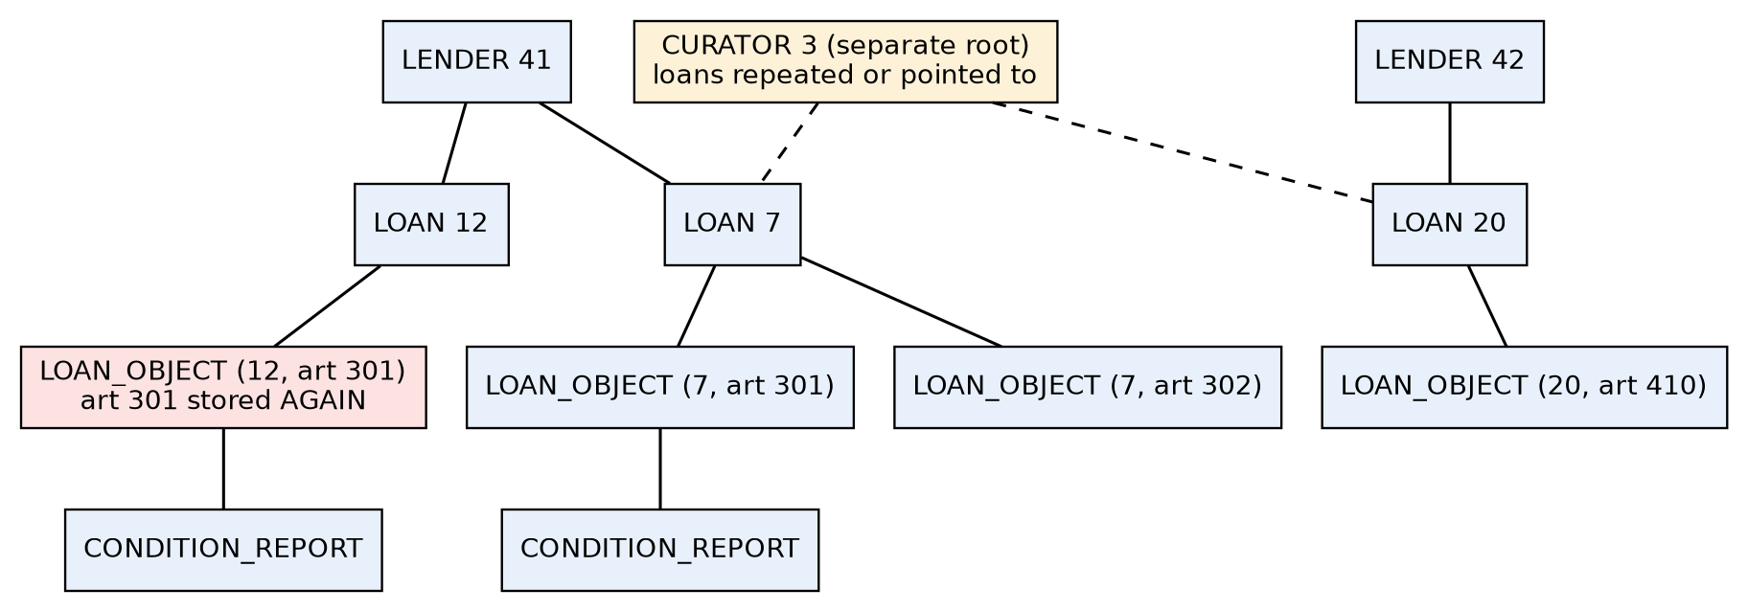
Figure 5 – Hierarchical representation: LENDER → LOAN → LOAN_OBJECT → CONDITION_REPORT. CURATOR is a second parent of LOAN, so loans must be repeated or reached by virtual pointer; artifact 301 is stored again under loan 12.
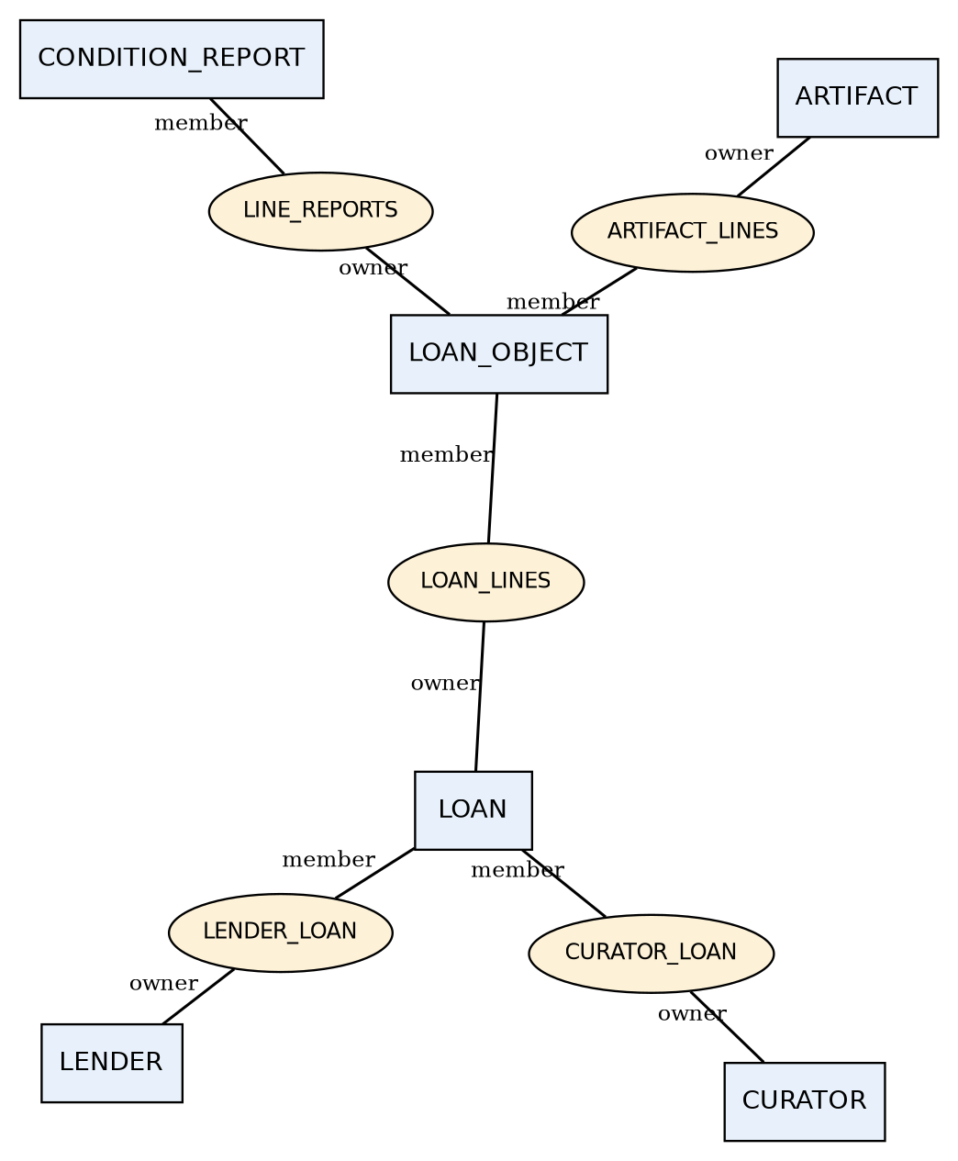
Figure 6 – Network representation with owner–member sets; LOAN is a member of both LENDER_LOAN and CURATOR_LOAN, LOAN_OBJECT of both LOAN_LINES and ARTIFACT_LINES.
Question | File processing | Hierarchical (tree) | Network (owner–member sets) | Relational (chosen)
One loan, two parents (lender and curator) | Lender and curator ids copied into every loan record | Only one parent allowed: loans duplicated under curator tree or linked by virtual pointer | LOAN is member of LENDER_LOAN and CURATOR_LOAN: natural | Two foreign keys on LOAN
Object on many loans (artifact on successive loans) | Artifact details repeated in every loan record (title can drift) | Artifact stored under every loan line (stored again) or logical relationship | LOAN_OBJECT is member of LOAN_LINES and ARTIFACT_LINES: no duplication | LOAN_OBJECT with composite PK; one ARTIFACT row
Person participates in several LOAN occurrences | Repeated name/address in each loan record | Fine for one role; a curator who also lends exists in two trees | One PERSON record owns both sets; set-chain navigation needed | One PERSON row, two role tables, any number of loans
Ad hoc query not on the access path | Program must be written | Navigation must start at a root | Navigation by programmer, DML loops | Declarative SQL + optimiser

10.2 Two case queries traced through each model
Step | Q1 – overdue loans still open | Q4 – inventory of exhibition 1 through placements
File processing | Sequentially read the whole loan file; for each record test status = ACTIVE and expiry < today; look up the lender name in a lender file (duplicate copies possible) | Read the placement file for exhibition 1; for each record search the artifact file by catalog number; the gallery plan’s copy of the title may differ from the loan register’s
Hierarchical | Open every LENDER root, walk each LOAN child (GN/GNP calls), test the fields; no direct entry by status; to print the curator, follow a virtual pointer to the CURATOR tree | Enter the EXHIBITION root → DISPLAY_SLOT children → placed-object leaf; the artifact title lives under a different root (the lender’s loans), so a logical-child pointer is needed
Network | FIND each LENDER owner, walk the LENDER_LOAN set to its LOAN members, test status/expiry; a SYSTEM set on status would be needed to avoid scanning all loans | FIND EXHIBITION 1, walk EXHIBITION_SLOT, then SLOT_PLACEMENT, then follow LINE → ARTIFACT_LINES owner to the title
Relational (measured) | One SQL statement over ix_loan_status_expiry: 91 rows at 1,000 lenders, 1.06 ms median | One four-table join on primary keys: 50 rows, 0.79 ms median (flat from 100 to 100,000 lenders)

10.3 Operational view, conceptual model and indexed internal representation
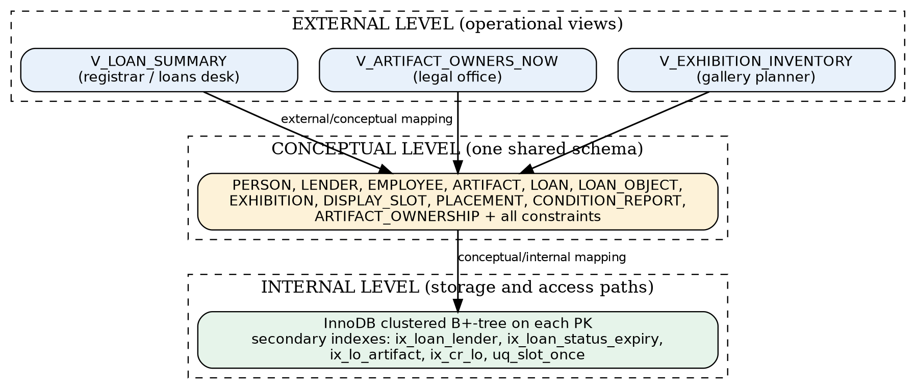
Figure 7 – Three-schema architecture for Meridian Museum.
Level | Meridian Museum content
External (operational view) | V_LOAN_SUMMARY gives the loans desk one row per loan (lender name, period, status, artifact count, total insured) without exposing keys of lower tables; the registrar sees condition reports through LOAN_OBJECT; the legal office sees V_ARTIFACT_OWNERS_NOW (Task 12)
Conceptual (shared model) | The 14 relations, keys and constraints of Task 7/8, common to every user group; one definition of ARTIFACT replaces the two catalogue descriptions
Internal (indexed representation) | InnoDB clustered B+-tree on every primary key; secondary indexes ix_loan_lender, ix_loan_status_expiry, ix_lo_artifact, ix_cr_lo and the unique indexes uq_slot_once, catalog_no, email; changing an index does not change any view or query (physical data independence)

10.4 DBMS components that coordinate a concurrent update
Suppose two registrars update the same LOAN row at once (one extends loan_expiry, the other sets status to RETURNED with a return date). The query processor parses and plans both statements; the transaction manager wraps each in a transaction; the lock manager gives the first an exclusive row lock on that LOAN row (two-phase locking) and makes the second wait, so a lost update cannot happen; the integrity manager evaluates ck_loan_period and ck_loan_status on the new row image and the foreign-key checks; the buffer manager brings the page into memory; the recovery manager writes redo/undo log records before commit so a crash cannot leave a half-applied change; readers meanwhile see a consistent snapshot through multi-version concurrency control. For custody periods this guarantees that a loan never has two competing expiry dates; for condition evidence it guarantees that a report row is never attached to a loan line that is being removed. *(This paragraph describes the engine’s documented behaviour; it was not benchmarked in this assignment.)*

Task 11 – Recommend and Defend the Final Design [4 Marks]
QUESTION | TASK 11 – Recommend and Defend the Final Design [4 Marks]
Recommend one alternative for Meridian Museum using the schema, query outputs and constraint tests. Defend keeping custody evidence distinct from ownership history.
Discuss:
• Explain which alternative best preserves custody periods and condition evidence.
• Trace the requirements to specific entities, keys and association records. Illustrate this through custody periods and condition evidence.
• Use actual results from the implementation and distinguish them from untested business assertions. Use the case issue of custody periods and condition evidence.
• Identify cross-table rules and identity assumptions that remain limitations. Relate this to custody periods and condition evidence.
• Assess the implications of growing the generated lender population to 100,000. Illustrate this through custody periods and condition evidence.
Defend the design through the case evidence rather than the number of relations. Relate this to custody periods and condition evidence.
Evidence Expected
A technically justified final design supported by modelling arguments and validation evidence.

ANSWER

11.1 Recommendation
Recommended design: Alternative C – independently identified LOAN, LOAN_OBJECT as an existence-dependent line, DISPLAY_SLOT weak under EXHIBITION, CONDITION_REPORT owned by the physical object on a loan, and PERSON generalising lenders and employees. It best preserves custody periods and condition evidence because the period belongs to one LOAN occurrence and the evidence belongs to (loan_id, artifact_id), so neither can be mixed up across lenders, loans or artifacts. Alternative A cannot show that two artifacts belong to one loan; Alternative B has no artifact in its core and produced a spurious tuple (Task 3).

11.2 Traceability: requirement → construct → key → evidence
Requirement | Entity / association | Key | Evidence (actual)
Loan belongs to one lender, has many artifacts | LOAN, LOAN_OBJECT | loan_id; (loan_id, artifact_id) | Join loan ⋈ loan_object = 6,020 rows = loan_object rows (Table 9.2b)
Successive loans of one artifact | LOAN_OBJECT rows per artifact | (loan_id, artifact_id) | 1,361 artifacts on 2+ loans; Q8 finds 0 overlaps
Display slots numbered within an exhibition | DISPLAY_SLOT (weak) | (exhibition_id, slot_no) | Slot numbers repeat in all exhibitions; invalid slot rejected (error 1452); occupied slot rejected (1062)
Condition reports by object, not lender name | CONDITION_REPORT → LOAN_OBJECT | report_id; FK (loan_id, artifact_id) | Report for an artifact not on the loan rejected (1452); Q2 lists the lines without evidence
Curator may lend a private object | PERSON + LENDER + EMPLOYEE (overlap) | person_id | Q7 returns 3 curator-lenders at every size
Expiry linked to display slots | PLACEMENT dates vs LOAN dates | (loan_id, artifact_id) | Q6 returns 0 placements outside their loan period
One current lender per artifact | ARTIFACT.lender_id | artifact_id | FK to LENDER; deletion of a lender with artifacts rejected (1451)

11.3 Tested results versus untested assertions
Tested (actual execution) | Asserted only (not tested here)
Row counts at four sizes; all FKs and CHECKs accepted the generated data | That real museum data would be as clean as generated data
13 invalid writes rejected with the messages in Task 8; 2 cross-table rules accepted silently and then blocked by triggers | That the two triggers cover every path (bulk loads, updates of loan dates after lines exist)
8 queries, counts, joins, median times at 100 → 100,000 lenders | Behaviour under many simultaneous registrars (only an 8-session id-allocation test was run)
Flat-file anomalies reproduced | That users would stop using the flat file once the schema exists

11.4 Remaining limitations
- Cross-table rules (curator role, no overlapping loans, placement within loan and exhibition dates, report date within the loan, at least one line per active loan) need triggers or audits; they are not declarative constraints.
- Identity assumptions: two PERSON rows for the same human are not detected (271 name pairs repeat at 1,000 lenders; they may be different people). The museum’s own catalogue numbers are assumed unique and correct; the catalogue-description mismatch is solved by a single ARTIFACT row but someone must still maintain it.
- Exhibition dates are not tied to slot occupancy; ‘lender equals owner’ was an assumption of the first design that Task 12 removes.

11.5 Implications of growing to 100,000 lenders
Measure | 1,000 lenders | 100,000 lenders | Meaning for custody / evidence
Loans | 2,011 | 200,252 | Linear growth; each loan stays a single row
Loan lines (objects on loan) | 6,020 | 584,295 | About 5.8 lines per lender
Condition reports | 9,690 | 945,371 | Largest table; most evidence
Lines on ACTIVE/RETURNED loans with no report | 261 | 25,166 | Evidence gaps to chase: Q2 returns 13,389 artifacts
Q1 overdue loans (median ms) | 1.06 | 107.53 | Index keeps it interactive
Q3 loan summary (median ms) | 15.03 | 9514 | Aggregating every loan through a view becomes slow (about 9.5 s); a summary table or a date filter is advisable
Q2 evidence gaps (median ms) | 7.55 | 1784 | About 1.8 s: acceptable as a batch audit, not as a screen

The design is defended by these case results (identity, participation and evidence queries) and not by the number of relations (14 tables plus one in Task 12): an extra table is justified only where it removes a failure case shown above.

Task 12 – Re-evaluate and Adapt the Design [8 Marks]
QUESTION | TASK 12 – Re-evaluate and Adapt the Design [8 Marks]
Changed Requirement
Artifacts may have shared legal ownership, and ownership shares can change while an existing loan remains in force. The custody record must remain distinct from the ownership history.
Reassess the original loan coordination model under this new requirement.
You may:
RETAIN, MODIFY, or REDESIGN
the original model, with a reasoned decision.
A. Impact Analysis – 2 Marks
Discuss:
• Identify the original assumption invalidated by the new requirement. Use the case issue of custody periods and condition evidence.
• Locate the affected entities, associations, business keys and temporal rules. Relate this to custody periods and condition evidence.
• Explain why the old identifier alone no longer describes the required fact. Illustrate this through custody periods and condition evidence.
• Trace the change through operational views, conceptual relations and internal access paths. Use the case issue of custody periods and condition evidence.
Evidence Expected
A clear analysis of how the changed requirements affect the original design.
B. Evaluation of the Original Design – 2 Marks
Assess whether your recommended design still represents the changed Meridian Museum rules.
Discuss:
• Test the original EXHIBITION representation against the new situation. Relate this to custody periods and condition evidence.
• Distinguish stable primary keys from constraints that must change. Illustrate this through custody periods and condition evidence.
• Reconsider the two rejected alternatives using the new rule. Use the case issue of custody periods and condition evidence.
Evidence Expected
A technically supported evaluation of the suitability of the original design under the new operating conditions.
C. Adaptation or Redesign – 2 Marks
Decide whether to:
Retain, extend or replace the model of Meridian Museum.
If you modify or redesign it:
• Show the revised EER construct that represents ARTIFACT_OWNER. Illustrate this through custody periods and condition evidence.
• Explain which old association is replaced, extended or versioned. Use the case issue of custody periods and condition evidence.
• Describe migration of existing records while preserving historical evidence. Relate this to custody periods and condition evidence.
• If retaining the model unchanged, demonstrate how it already represents the new facts. Illustrate this through custody periods and condition evidence.
Evidence Expected
An appropriate design response to the changed requirement, with clear database-design reasoning.
D. Evidence-Based Defence – 2 Marks
Defend the revised design for Meridian Museum with traceable evidence.
Use:
• Use the new identity and participation rules. Use the case issue of custody periods and condition evidence.
• Specify a query that would reveal an incorrect migration. Relate this to custody periods and condition evidence.
• Explain the effect on generated data and relationship counts. Illustrate this through custody periods and condition evidence.
• Show how existing operational views can preserve their interface. Use the case issue of custody periods and condition evidence.
• State the cost of the extra association and history checks. Relate this to custody periods and condition evidence.
• Relate the final decision directly to the changed requirement. Illustrate this through custody periods and condition evidence.
Evidence Expected
A well-supported final design decision integrating theoretical analysis, experimental evidence and the changed system constraints.

ANSWER
Decision: MODIFY (extend). The core of the model is retained; one new association, ARTIFACT_OWNERSHIP, is added and the meaning of ARTIFACT.lender_id is narrowed from ‘owner’ to ‘lender of record’. A full redesign is not needed because custody (LOAN, LOAN_OBJECT), placement and condition evidence do not depend on who owns the artifact.

A. Impact analysis (2 marks)
- Invalidated assumption: that the single ‘current lender’ of an artifact also stands for the owner (one owner, one value at a time). With shared legal ownership and changing shares, ownership is a *set of (owner, share) facts that vary over time*.
- Affected parts: ARTIFACT.lender_id (CURRENT_LENDER association), LOAN.lender_id (must now be a current owner or authorised agent – a new cross-table rule), V_ARTIFACT/V_LOAN_SUMMARY wherever the lender name is printed as ‘owner’, and the temporal rule that ownership periods must be gap-free and total 100% at every date. Not affected: LOAN period, LOAN_OBJECT, PLACEMENT, DISPLAY_SLOT, CONDITION_REPORT.
- Why the old identifier is not enough: artifact_id (or artifact + lender) identifies the object, not the fact ‘owner O held s% from date d’. That fact needs (artifact_id, owner_id, valid_from); with only the old identifiers a change from 60/40 to 50/50 would overwrite the history that an existing loan was signed under.
- Trace: operational views – the legal office needs V_ARTIFACT_OWNERS_NOW, the loans desk’s V_LOAN_SUMMARY must stay unchanged; conceptual relations – add ARTIFACT_OWNERSHIP with FKs to ARTIFACT and PERSON; internal access path – unique index (artifact_id, owner_id, valid_from) and a lookup by (artifact_id, valid_to IS NULL) for ‘current owners’.

B. Evaluation of the original design (2 marks)
- EXHIBITION and placement: tested against the new rule they stay valid. A placement refers to a LOAN_OBJECT and a slot; ownership shares can change while the object sits in the slot, without altering the placement. If an exhibition credit line must name owners, it is obtained by joining ARTIFACT_OWNERSHIP at the display date (a query, not a column).
- Stable keys: person_id, artifact_id, loan_id, (loan_id, artifact_id), (exhibition_id, slot_no), report_id and catalog_no do not change. Must change: the meaning/constraints of ARTIFACT.lender_id (‘one current lender’ is now ‘lender of record’), and a new rule that LOAN.lender_id is an owner or the agent for the owners at loan_start.
- Rejected alternatives reconsidered: in A, the dated LENDS tuple would multiply into one tuple per artifact × owner × loan and still mix custody with ownership; in B, the ternary (lender, curator, exhibition) has nowhere to hold shares. Both get worse under the new rule, which confirms the earlier rejection.

C. Adaptation (2 marks)
Item | Revised design
Revised EER construct | ARTIFACT_OWNERSHIP: a temporal (versioned) M:N association between ARTIFACT and PERSON, drawn as an associative entity with attributes share_pct, valid_from, valid_to; key (ownership_id) and unique (artifact_id, owner_id, valid_from). Each version is closed (valid_to set) and a new version inserted when a share changes.
Old association | CURRENT_LENDER (ARTIFACT–LENDER): extended, not deleted – it now means lender of record (custody). Its role as ‘owner’ is replaced by ARTIFACT_OWNERSHIP, which is versioned.
Unchanged | LOAN, LOAN_OBJECT, PLACEMENT, DISPLAY_SLOT, CONDITION_REPORT, PERSON, EXHIBITION

CREATE TABLE artifact_ownership (
ownership_id INT UNSIGNED AUTO_INCREMENT PRIMARY KEY,
artifact_id INT UNSIGNED NOT NULL,
owner_id INT UNSIGNED NOT NULL,
share_pct DECIMAL(5,2) NOT NULL,
valid_from DATE NOT NULL,
valid_to DATE NULL,
CONSTRAINT ck_own_share CHECK (share_pct > 0 AND share_pct <= 100),
CONSTRAINT ck_own_period CHECK (valid_to IS NULL OR valid_to > valid_from),
CONSTRAINT uq_own_version UNIQUE (artifact_id, owner_id, valid_from),
CONSTRAINT fk_own_art FOREIGN KEY (artifact_id) REFERENCES artifact(artifact_id),
CONSTRAINT fk_own_owner FOREIGN KEY (owner_id) REFERENCES person(person_id)
) ENGINE=InnoDB;

Migration of existing records (executed on all four databases). (1) Create the table. (2) For every artifact insert one row: owner = the existing lender, share 100%, valid_from = the lender’s lender_since date (the earliest date the museum knows of the relationship), valid_to = NULL. (3) Do not touch LOAN, LOAN_OBJECT, PLACEMENT or CONDITION_REPORT. (4) Verify counts and totals. Step (2) created 742, 7,656, 74,828 and 750,870 ownership rows for 100, 1,000, 10,000 and 100,000 lenders (one per artifact) in 0.01, 0.08, 0.59 and 5.15 seconds.
To exercise the new rule, shared ownership was then generated: every 10th artifact was split 60/40 with a second owner from 2026-03-01, and every 50th artifact’s shares were changed again to 50/50 on 2026-09-01, each time closing the old version and inserting new ones, while the artifact’s loans stayed in force.

D. Evidence-based defence (2 marks)
Measure | 100 | 1,000 | 10,000 | 100,000
Artifacts (= migrated 100% rows) | 742 | 7,656 | 74,828 | 750,870
Ownership rows after splits and share changes | 918 | 9,492 | 92,784 | 931,078
Artifacts with 2 current owners | 74 | 765 | 7,482 | 75,087
Artifacts whose shares changed on 2026-09-01 | 14 | 153 | 1,496 | 15,017
Split artifacts with a loan in force on 2026-03-01 | 6 | 39 | 362 | 3,804
LOAN / LOAN_OBJECT / REPORT / PLACEMENT counts before = after | yes | yes | yes | yes
Extra rows vs. before (ownership rows ÷ artifacts) | 1.24× | 1.24× | 1.24× | 1.24×

Table 12.1 – effect on generated data and relationship counts. Custody, placement and evidence counts are identical before and after (the ‘yes’ row compares the counts of loan, loan_object, condition_report, placement and the checksum of V_LOAN_SUMMARY). Only the ownership relationship grows, by 1.24× at every size.

Identity and participation rules used
- ARTIFACT 1 : N ARTIFACT_OWNERSHIP (total on the ownership side; every artifact has at least one version at every date after its first); PERSON 1 : N ARTIFACT_OWNERSHIP.
- Unique (artifact_id, owner_id, valid_from): the same owner cannot have two versions starting the same day.
- At every date d the shares of the versions valid at d total exactly 100%, and at least one version exists. This is a cross-table rule (not a CHECK) and is enforced by the audit query below.

Query that reveals an incorrect migration
-- artifacts whose current shares do not total 100% on date :d
SELECT artifact_id, SUM(share_pct) AS total_share
FROM artifact_ownership
WHERE valid_from <= :d AND (valid_to IS NULL OR valid_to > :d)
GROUP BY artifact_id HAVING SUM(share_pct) <> 100;

-- artifacts with no owner at all on :d (gap)
SELECT a.artifact_id FROM artifact a WHERE NOT EXISTS (
SELECT 1 FROM artifact_ownership o WHERE o.artifact_id=a.artifact_id
AND o.valid_from <= :d AND (o.valid_to IS NULL OR o.valid_to > :d));

Date :d | Artifacts with shares ≠ 100% | Artifacts with no owner (gap)
2018-01-01 | 0 | 4,369
2024-06-01 | 0 | 0
2026-02-01 | 0 | 0
2026-03-01 | 0 | 0
2026-06-15 | 0 | 0
2026-09-01 | 0 | 0
2026-11-01 | 0 | 0

Table 12.2 – audit results at 1,000 lenders (the same zero/zero result holds at every size for dates from 2024-06-01 onwards). A correct migration returns 0 share errors on every date. The 2018-01-01 gap count is expected: it is earlier than any lender’s registration, so no owner existed in the museum’s records – the query correctly reports it. To prove the audit works, a wrong migration was simulated by inserting a second 100% row for artifact 5: the share query returned 5 (total share 200.00); the row was then removed.

History and the current-owner view (actual output, 1,000 lenders)
artifact_id | owner_id | share_pct | valid_from | valid_to
20 | 3 | 100.00 | 2018-04-26 | 2026-03-01
20 | 3 | 60.00 | 2026-03-01 | –
20 | 301 | 40.00 | 2026-03-01 | –
50 | 44 | 100.00 | 2015-01-23 | 2026-03-01
50 | 44 | 60.00 | 2026-03-01 | 2026-09-01
50 | 691 | 40.00 | 2026-03-01 | 2026-09-01
50 | 44 | 50.00 | 2026-09-01 | –
50 | 691 | 50.00 | 2026-09-01 | –

Artifact 20 shows one split (100% → 60/40 on 2026-03-01); artifact 50 shows the split and the later share change (60/40 → 50/50 on 2026-09-01) with the first versions closed rather than overwritten.
artifact_id | catalog_no | owner_name | share_pct
20 | MM-0000020 | Dev Gupta | 60.00
20 | MM-0000020 | Rahul Khan | 40.00
50 | MM-0000050 | Karthik Sharma | 50.00
50 | MM-0000050 | Nila Reddy | 50.00

Preserving the operational interface. V_LOAN_SUMMARY, the loans desk’s view, was not changed and returns the same checksum before and after migration (the ‘yes’ row of Table 12.1); the sample below is its unchanged output. Ownership questions use the new view V_ARTIFACT_OWNERS_NOW, so no existing report or program has to be rewritten.
loan_id | lender_name | loan_start | loan_expiry | status | artifact_count | total_insured
1 | Aarav Shah | 2025-04-25 | 2025-12-26 | RETURNED | 2 | 140888.55
2 | Sana Kapoor | 2023-05-15 | 2024-02-10 | RETURNED | 3 | 109301.22
3 | Sana Kapoor | 2024-03-01 | 2024-10-30 | RETURNED | 4 | 409732.92

Cost of the extra association and history checks
Cost item | 100 | 1,000 | 10,000 | 100,000
Share-total audit, median ms (date 2026-11-01) | 0.8 | 8.1 | 118.7 | 1116.7
Gap audit, median ms (date 2026-11-01) | 0.6 | 5.4 | 46.5 | 2111.9
Extra rows (ownership rows − artifacts) | 176 | 1,836 | 17,956 | 180,208
Writes per share change | 1 close + n inserts | 1 close + n inserts | 1 close + n inserts | 1 close + n inserts

The price of the design is one more table (about 1.24 rows per artifact), a two-step write for each change of shares (close old version, insert new), and two audit queries that take about 1.1 s and 2.0 s at 100,000 lenders – acceptable as a nightly or pre-loan check, not as a per-screen query. In return, history is kept: no loan has to be edited, and no report loses its meaning when a share changes.

Final decision related to the changed requirement
Because shared ownership with changing shares is a different fact from custody, the model was extended, not rewritten: ARTIFACT_OWNERSHIP records who owned what share and when, while LOAN/LOAN_OBJECT still record who had the object and when, and CONDITION_REPORT still records what state it was in. The migration changed no custody or evidence row, the loans desk’s view is unchanged, and a single audit query detects an incorrect migration. That keeps the custody record distinct from the ownership history, which is the changed requirement.



